2026 AdventHealth 2nd Annual Sepsis Symposium Surviving the Storm (AHC)
Date/Time: | 9/24/2026 7:15:00 AM | Activity ID: | 24282
Location: | Orlando College of Osteopathic Medicine
Topic | Every Minute Matters in Sepsis Care . . . Every Decision Matters More  Join us for the 2nd Annual Sepsis Symposium and learn how to recognize sepsis sooner, communicate more effectively across care teams, and implement evidence-based treatment strategies that improve patient outcomes. Featuring expert faculty, interactive case discussions, ultrasound education, hands-on training, and immersive simulations, this two-day event delivers practical skills you can immediately apply in your clinical practice.
Objectives:
After this activity, the participant will be able to:

1 Identify and describe process barriers that affect timely recognition and treatment of sepsis.
2 Apply evidence-based treatment strategies for patients with sepsis, including appropriate antibiotic administration and fluid management.
Accreditation:



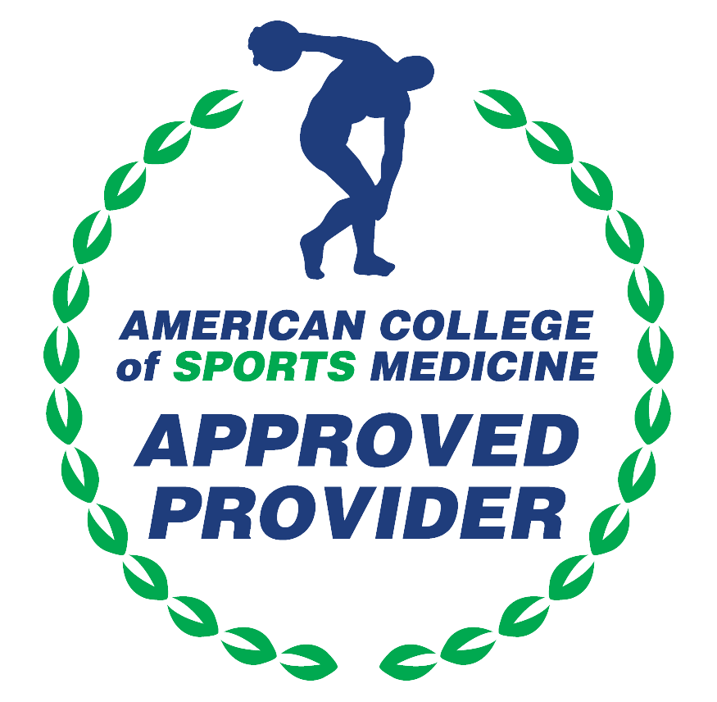

American Medical Association (AMA)
AdventHealth Orlando is accredited by the Florida Medical Association (FMA) to provide continuing medical education for physicians.
AdventHealth Orlando designates this Live Activity for a maximum of 14.00 AMA PRA Category 1 Credit(s)™. Physicians should claim only the credit commensurate with the extent of their participation in the activity.

American Osteopathic Association (AOA)
AdventHealth Orlando is accredited by the American Osteopathic Association to provide osteopathic continuing medical education for physicians.
AdventHealth Orlando designates this program for a maximum of 14.00 AOA Category 1-A credits and will report CME and specialty credits commensurate with the extent of the physician's participation in this activity.







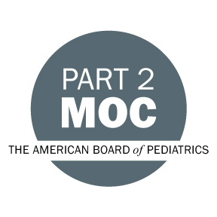

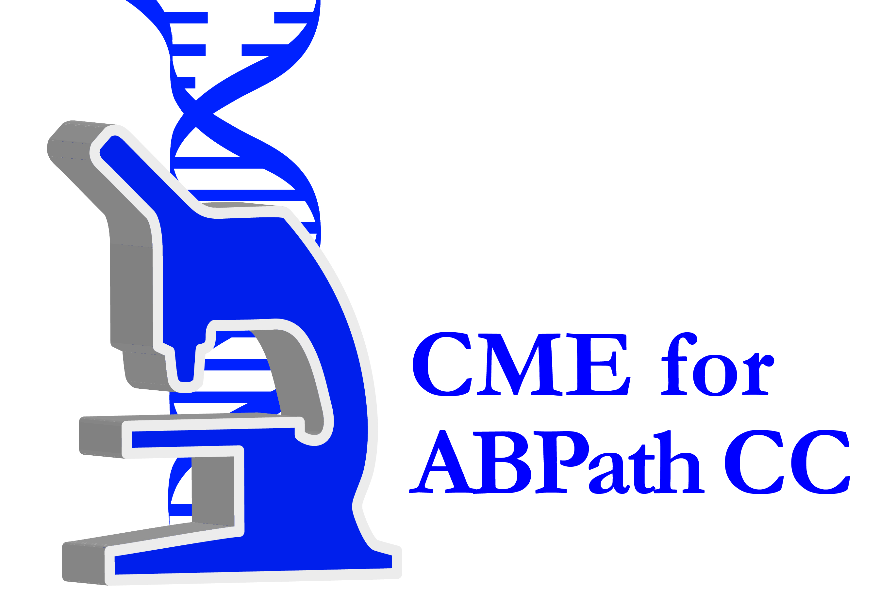

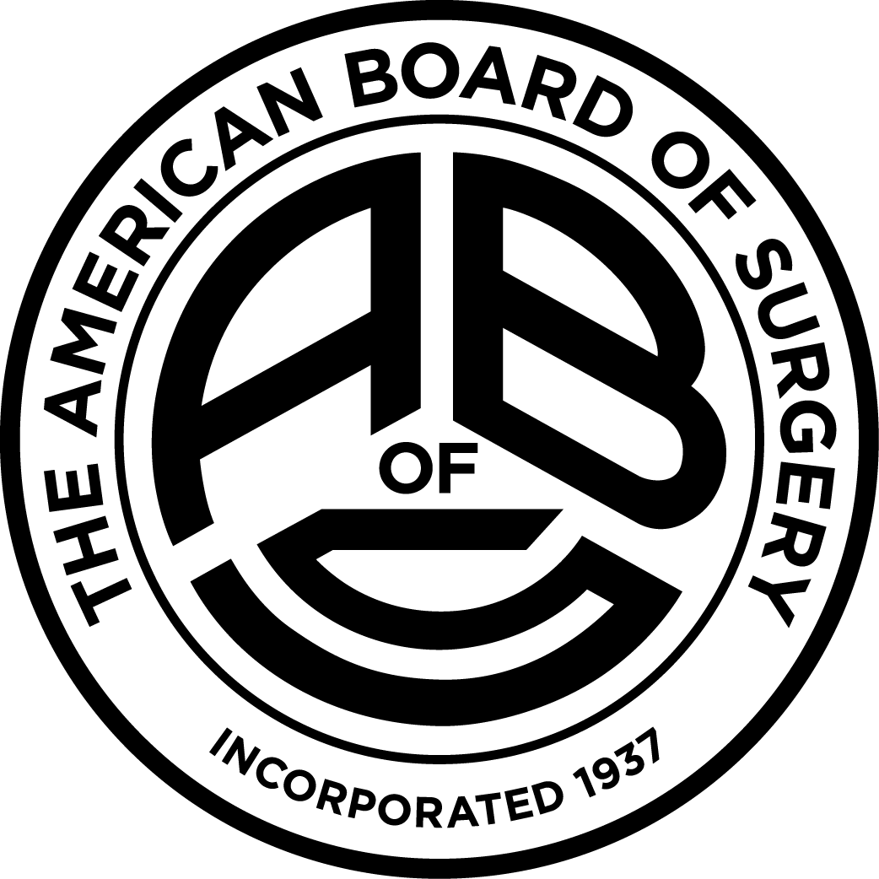

Other Healthcare Professionals
Other healthcare professionals who participate in this activity may submit their statement of participation to their appropriate accrediting organizations or state boards for consideration of credit. Participants are responsible for determining whether this activity meets the requirements for acceptable continuing education.
Disclosures:
AdventHealth Orlando CME adheres to the ACCME’s Standards for Integrity and Independence in Accredited Continuing Education. Any individuals in a position to control the content of a CE activity, including faculty, planners, reviewers or others are required to disclose all relevant financial relationships with ineligible entities (commercial interests). All relevant conflicts of interest have been mitigated prior to the commencement of the activity.

The planners and faculty of this series have disclosed the following financial relationship(s) with ineligible companies/commercial interests:
Name of individual | Individual's role in activity | Nature of Relationship(s) / Name of Ineligible Company(s)
Peter Antevy, MD | Faculty | Ownership-Pediatric Emergency Standards, Inc. - 08/10/2026
David Banks, MSW | Faculty | Nothing to disclose - 09/04/2026
Richard S Blumenthal, BA | Faculty | Employment - 09/17/2026
Rizwana Fareeduddin, MD | Faculty | Nothing to disclose - 07/12/2026
Leila Keeler, DO, FACOOG | Faculty | Nothing to disclose - 08/05/2026
Nicholas W. McAlister, DO | Faculty | Nothing to disclose - 08/11/2026
Christina A. Moreno, MSN, RN | Activity Coordinator, Faculty | Nothing to disclose - 07/10/2026
Hollis R. O'Neal Jr., MD, MSc | Faculty | Grant or research support-Cytovale, Inc|Advisor-Cytovale, Inc - 08/11/2026
Maria C. Pagano, MSN, RN | Faculty | Nothing to disclose - 07/29/2026
Daniel J. Peach, DO | Course Director, Faculty | Nothing to disclose - 07/29/2026
Jose L. Rosado, MD | Faculty | Nothing to disclose - 07/25/2026
Paige Stafford, Unknown | Faculty | Nothing to disclose - 08/11/2026
Stephanie Taylor, MD | Faculty | Nothing to disclose - 07/13/2026
Sean Tuetken, MBA | Faculty | Employment-Becton Dickinson & Company - 08/06/2026
Jody W. Webb, MBA, MSN, RN, RRT | Activity Coordinator, Faculty | Nothing to disclose - 09/04/2026

