2026 HRO Immersion Training (AH Central Texas)
Date/Time: | 5/26/2026 8:00:00 AM | Activity ID: | 24211
Location: | AdventHealth Avista
Topic | The HRO Immersion Training is a 6-week interactive program designed to translate High Reliability principles into real clinical practice. Participants engage in simulation, team exercises, and debriefs to strengthen communication, risk recognition, and decision-making. The program emphasizes practical application to improve safety, teamwork, and reliability in daily operations.
Objectives:
After this activity, the participant will be able to:

Accreditation:


ACPE Universal Activity Number (UAN): Technician:



American Medical Association (AMA)
AdventHealth Orlando is accredited by the Florida Medical Association (FMA) to provide continuing medical education for physicians.
AdventHealth Orlando designates this Live Activity for a maximum of 0.00 AMA PRA Category 1 Credit(s)™. Physicians should only claim the credit commensurate with the extent of their participation in the activity.







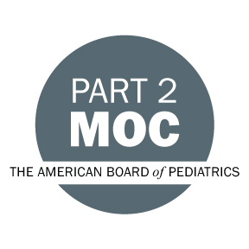





Other Healthcare Professionals
Other healthcare professionals who participate in this activity may submit their statement of participation to their appropriate accrediting organizations or state boards for consideration of credit. Participants are responsible for determining whether this activity meets the requirements for acceptable continuing education.
Disclosures:
AdventHealth Orlando CME adheres to the ACCME’s Standards for Integrity and Independence in Accredited Continuing Education. Any individuals in a position to control the content of a CE activity, including faculty, planners, reviewers or others are required to disclose all relevant financial relationships with ineligible entities (commercial interests). All relevant conflicts of interest have been mitigated prior to the commencement of the activity.

The planners and faculty of this series have disclosed the following financial relationship(s) with ineligible companies/commercial interests:
Name of individual | Individual's role in activity | Nature of Relationship(s) / Name of Ineligible Company(s)
Mildred Abodakpi, BSN | Faculty | Nothing to disclose - 04/30/2026
Brian Bebout, MBA | Faculty | Nothing to disclose - 04/28/2026
Jason Cirolia, PT | Faculty | Nothing to disclose - 04/29/2026
David A. George, BSN, RN, CCRN-K | Co-Director | Nothing to disclose - 04/28/2026
Erica K. Jacques, MBA | Faculty | Nothing to disclose - 04/29/2026
Camille Rey, MSN, BSN, RN | Faculty | Nothing to disclose - 04/29/2026
Korey M. Settle, MSN, RN, NC-BC, LSSGB | Faculty, Nurse Planner | Nothing to disclose - 04/28/2026

