2026 Navigating the Edge: Medical, Legal, and Ethical Challenges at the End of Life (CFD)
Date/Time: | 6/30/2026 7:30:00 AM | Activity ID: | 24176
Location: | AdventHealth Orlando
Topic | Join us as we step into the toughest decisions in medicine—where life, ethics, and law collide. Are you prepared to navigate end-of-life care when every choice matters?
Objectives:
After this activity, the participant will be able to:

1 Describe legal standards and institutional policies related to end-of-life care, including DNR/POLST, brain death, ECMO, and organ donation.
2 Apply ethical and legal frameworks to guide clinical decision-making in complex end-of-life scenarios.

3 Demonstrate effective communication strategies to manage disagreements and align care with patient goals.
4 Integrate institutional policies and interdisciplinary resources into end-of-life care planning to improve consistency in practice.
Accreditation:


ACPE Universal Activity Number (UAN): Technician:



American Medical Association (AMA)
AdventHealth Orlando is accredited by the Florida Medical Association (FMA) to provide continuing medical education for physicians.
AdventHealth Orlando designates this Live Activity for a maximum of 7.00 AMA PRA Category 1 Credit(s)™. Physicians should only claim the credit commensurate with the extent of their participation in the activity.







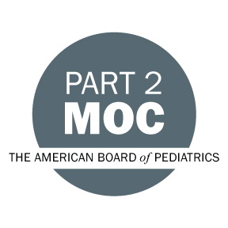

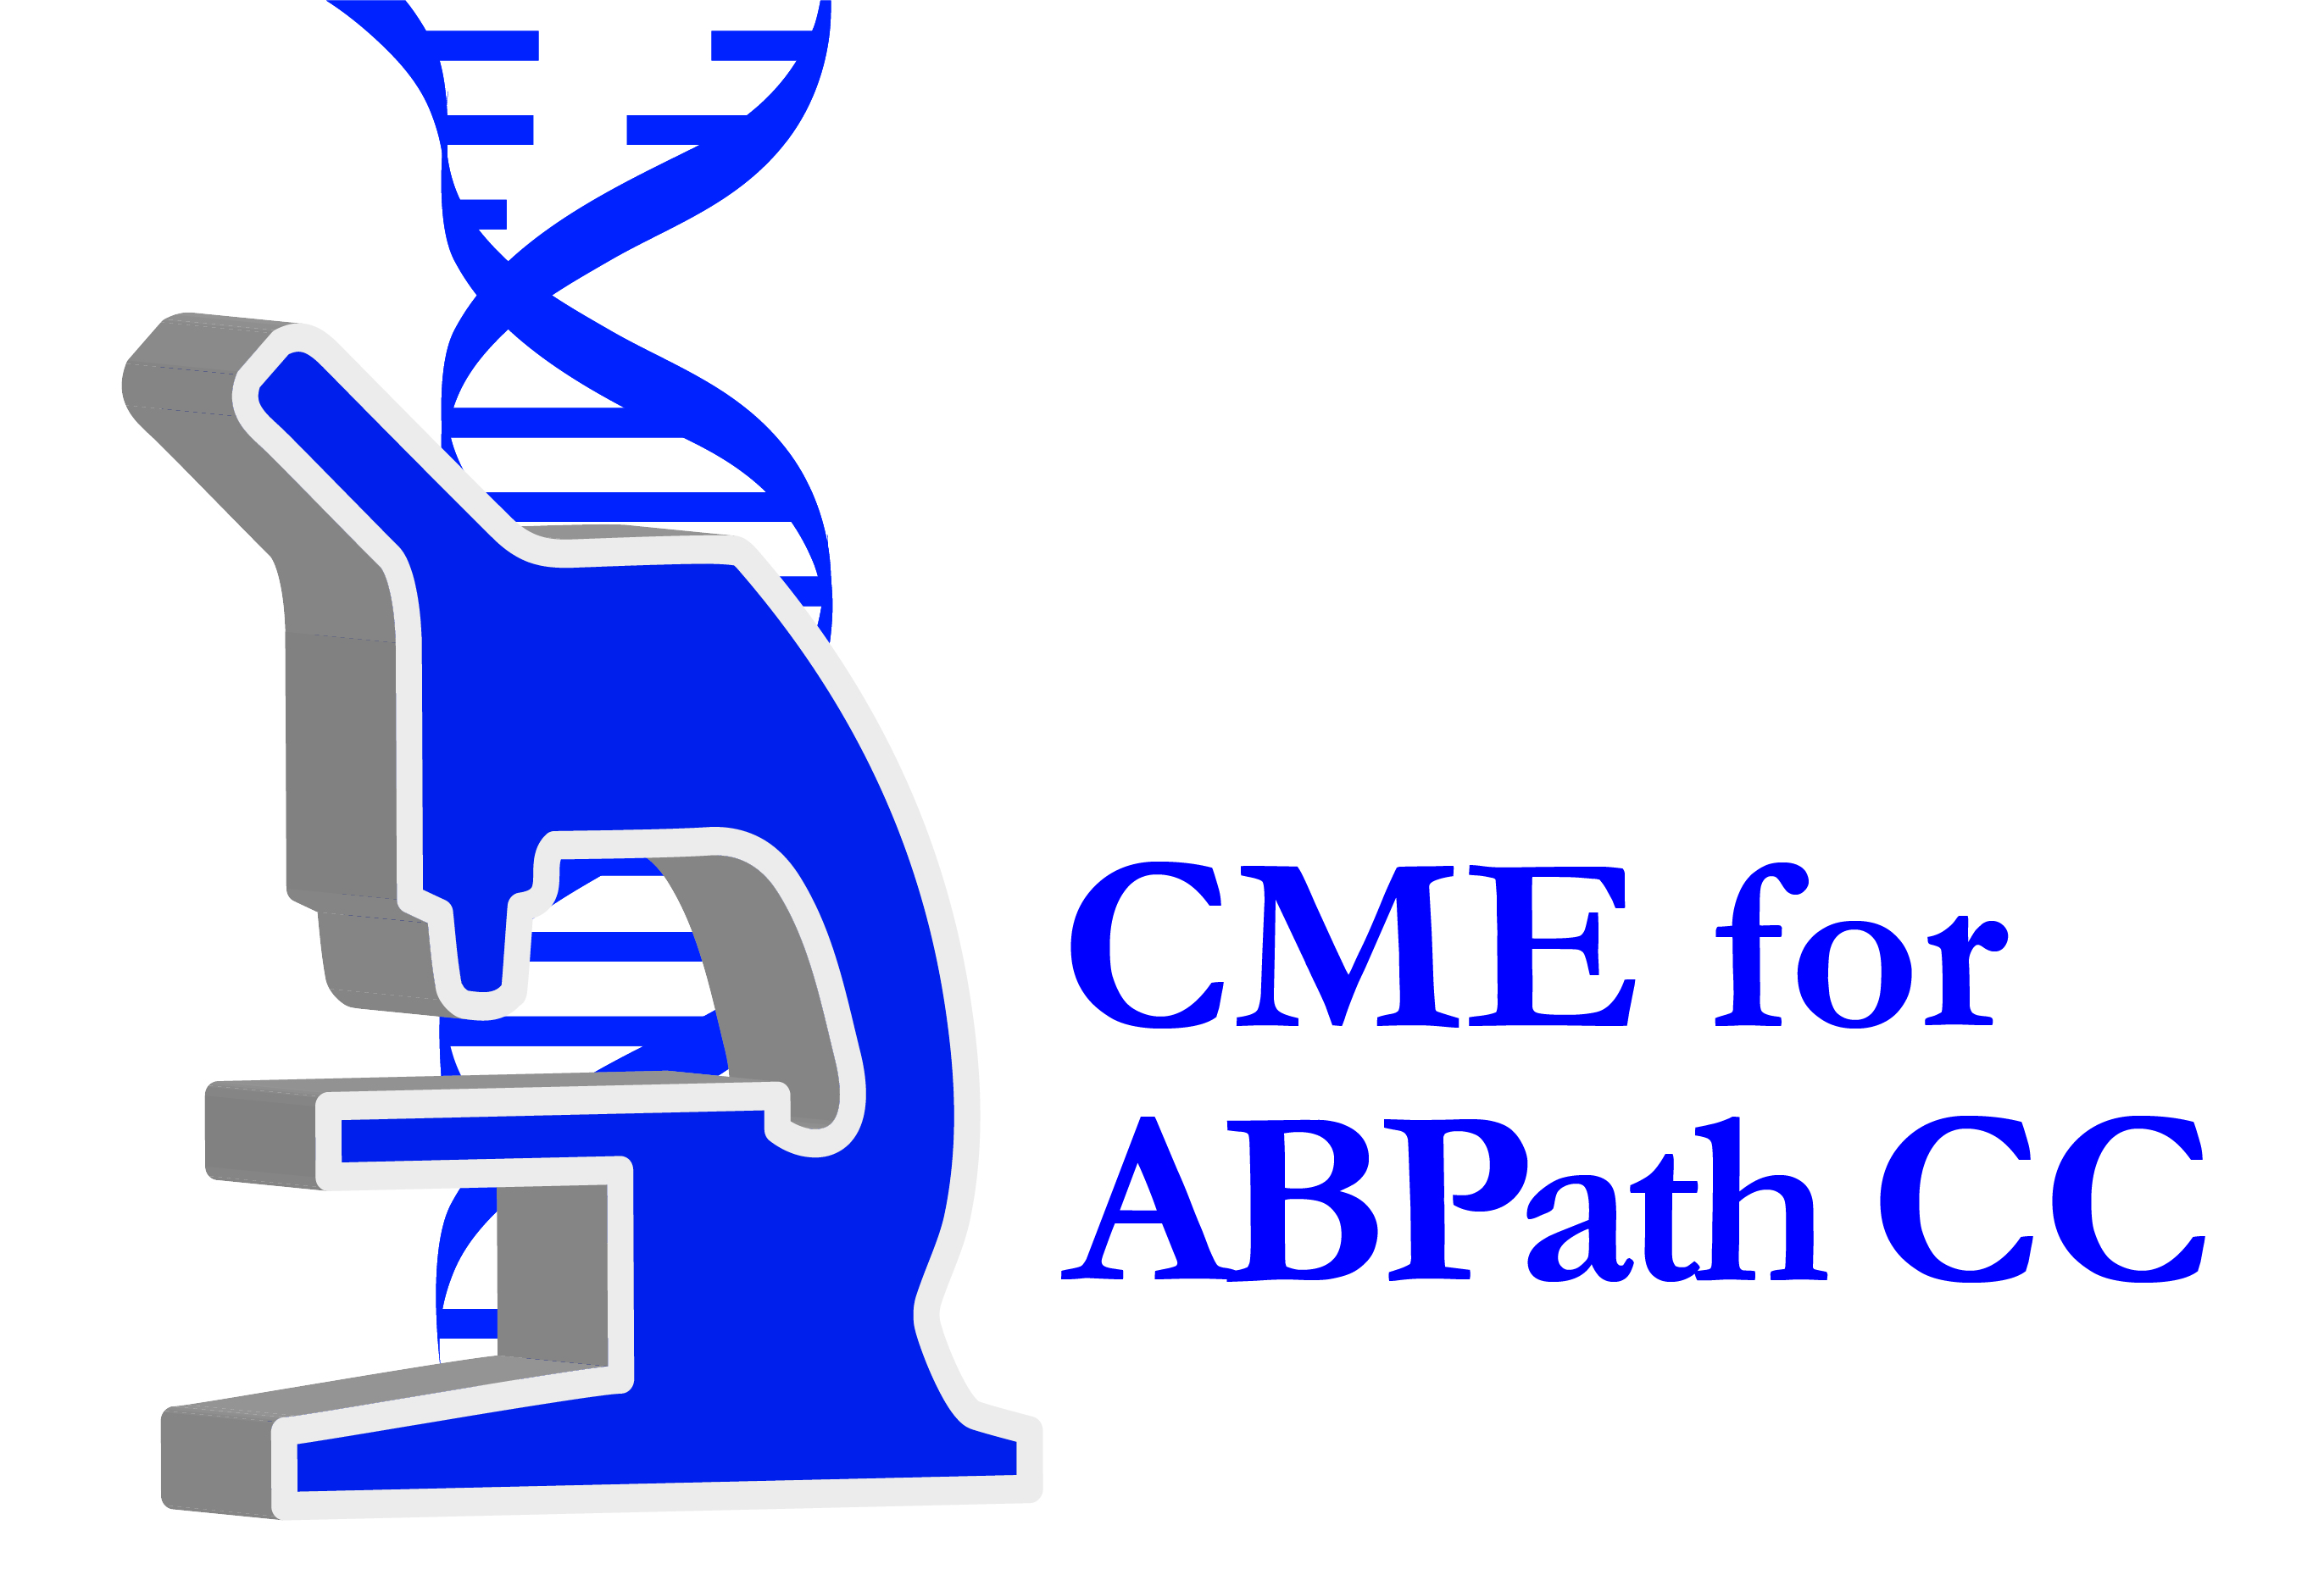

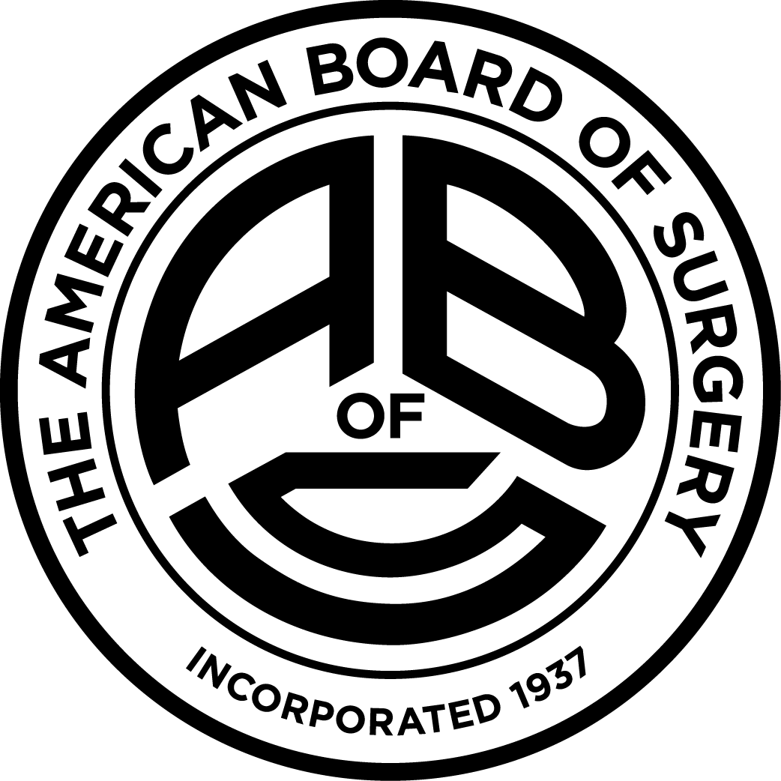

Other Healthcare Professionals
Other healthcare professionals who participate in this activity may submit their statement of participation to their appropriate accrediting organizations or state boards for consideration of credit. Participants are responsible for determining whether this activity meets the requirements for acceptable continuing education.
Disclosures:
AdventHealth Orlando CME adheres to the ACCME’s Standards for Integrity and Independence in Accredited Continuing Education. Any individuals in a position to control the content of a CE activity, including faculty, planners, reviewers or others are required to disclose all relevant financial relationships with ineligible entities (commercial interests). All relevant conflicts of interest have been mitigated prior to the commencement of the activity.

The planners and faculty of this series have disclosed the following financial relationship(s) with ineligible companies/commercial interests:
Name of individual | Individual's role in activity | Nature of Relationship(s) / Name of Ineligible Company(s)
Mehul Desai, MD | Faculty | Nothing to disclose - 06/09/2026
Kimberly Griggs, BSN, RN | Faculty | Nothing to disclose - 05/26/2026
Lexi Heller, BS | Activity Coordinator | Nothing to disclose - 05/26/2026
Jose Montenegro, MDiv | Faculty | Nothing to disclose - 05/26/2026
Sandra L. Muse, MSN | Nurse Planner | Nothing to disclose - 05/11/2026
Bobby N. Nibhanupudy, MD | Faculty | Nothing to disclose - 09/02/2025
Amay Parikh, MD, MBA, FACP | Course Director, Faculty | Nothing to disclose - 11/07/2025
Vinit Patil, MD | Faculty | Nothing to disclose - 06/05/2026
Clarissa Welbaum, MSN | Nurse Planner | Consulting Fee-Fresenius Medical Care (Relationship has ended) - 05/28/2026

