2026 Medicare Shared Saving Program (MSSP) Education - 04/20/2026
Date/Time: | 4/20/2026 12:30:00 PM | Activity ID: | 24110
Location: | Virtual Meeting
Topic | Join us as we equip clinicians with practical strategies to improve care for Medicare Shared Savings Program patients by completing Annual Wellness Visits, accurately capturing HCCs for appropriate RAF scores, and closing critical care gaps in preventive screenings and chronic disease management.
Objectives:
After this activity, the participant will be able to:

1 Apply evidence-based screening, chronic disease management, and accurate risk-adjusted documentation to close care gaps and improve outcomes for attributed patients.
Accreditation:


ACPE Universal Activity Number (UAN): Technician:



American Medical Association (AMA)
AdventHealth Orlando is accredited by the Florida Medical Association (FMA) to provide continuing medical education for physicians.
AdventHealth Orlando designates this Live Activity for a maximum of 1.50 AMA PRA Category 1 Credit(s)™. Physicians should only claim the credit commensurate with the extent of their participation in the activity.







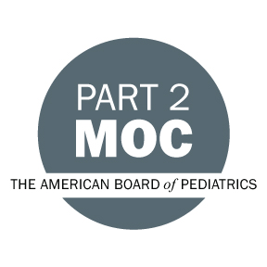

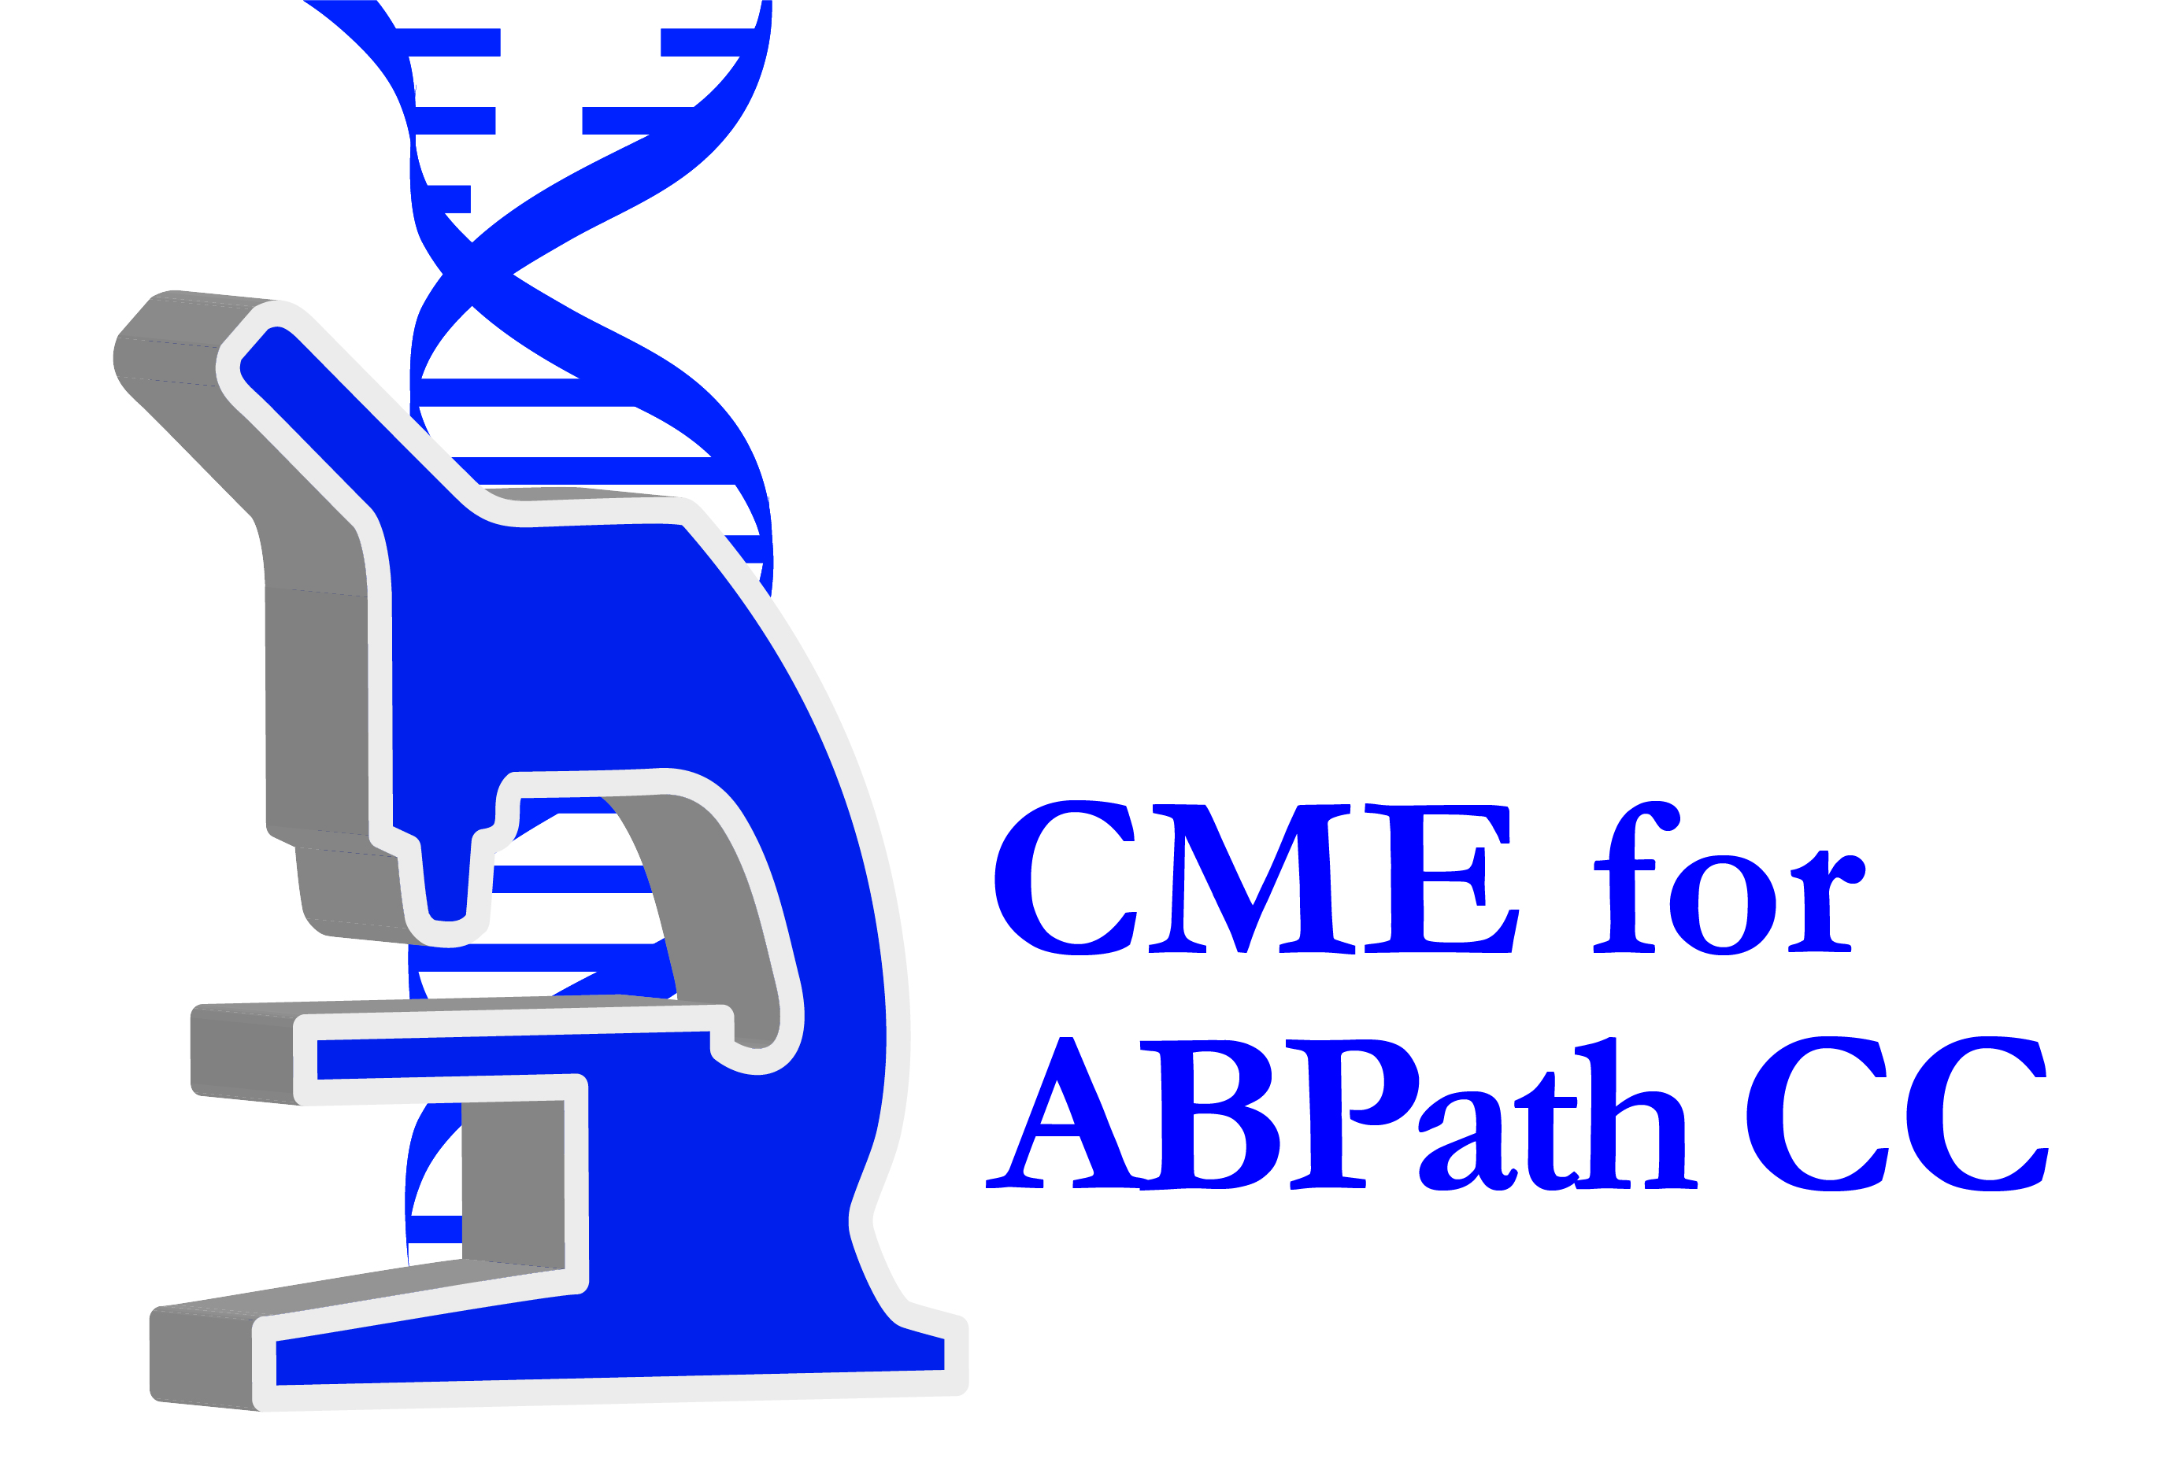

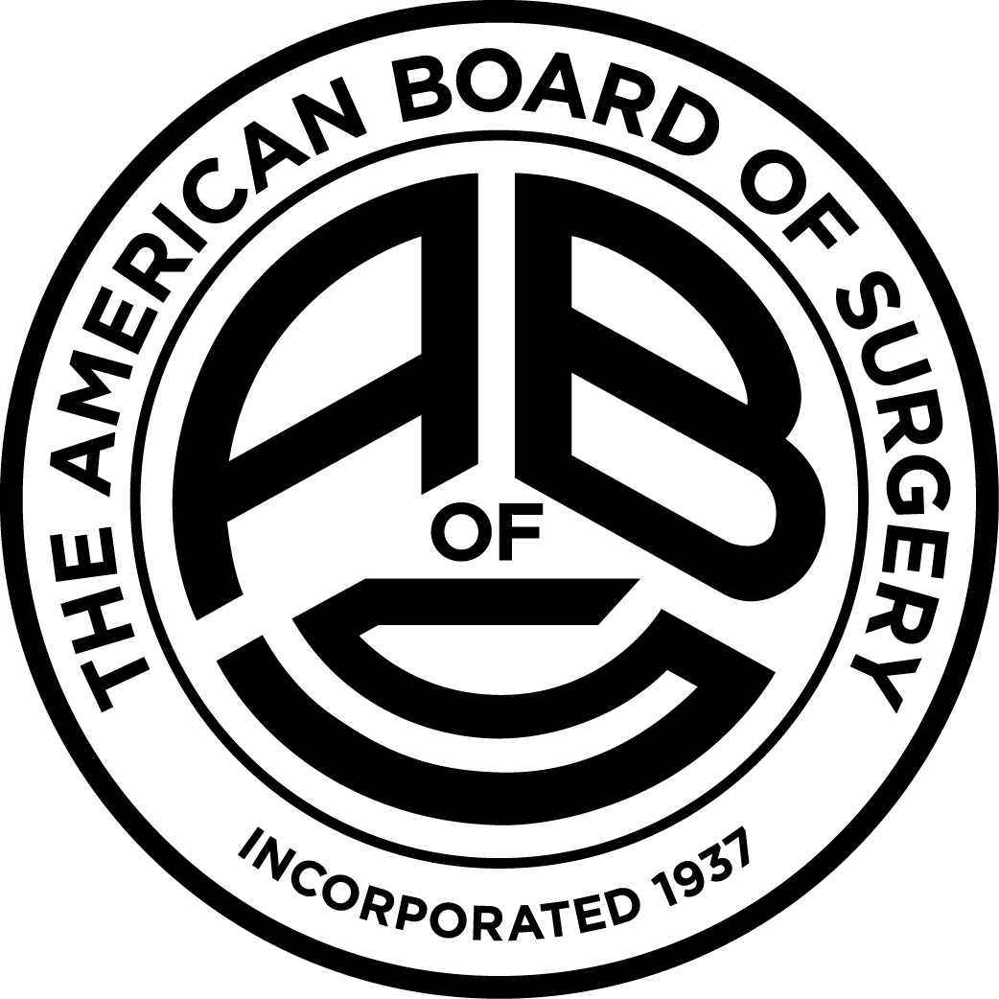

Other Healthcare Professionals
Other healthcare professionals who participate in this activity may submit their statement of participation to their appropriate accrediting organizations or state boards for consideration of credit. Participants are responsible for determining whether this activity meets the requirements for acceptable continuing education.
Disclosures:
AdventHealth Orlando CME adheres to the ACCME’s Standards for Integrity and Independence in Accredited Continuing Education. Any individuals in a position to control the content of a CE activity, including faculty, planners, reviewers or others are required to disclose all relevant financial relationships with ineligible entities (commercial interests). All relevant conflicts of interest have been mitigated prior to the commencement of the activity.

The planners and faculty of this series have disclosed the following financial relationship(s) with ineligible companies/commercial interests:
Name of individual | Individual's role in activity | Nature of Relationship(s) / Name of Ineligible Company(s)
Christopher R. Buelvas, MD | Co-Course Director, Faculty | Nothing to disclose - 09/10/2025
Angela M. English, BSN | Other Planning Committee Member | Nothing to disclose - 01/07/2026
Lana A. Massaro, MD | Course Director, Faculty | Nothing to disclose - 01/07/2026
Liz M. Price, MBA, MSN, RN | Other Planning Committee Member | Nothing to disclose - 02/09/2026
Robert M. Rodgers, MD | Co-Director | Nothing to disclose - 02/06/2026

