2026 AdventHealth Patient Safety Academy 9/15/26
Date/Time: | 9/15/2026 8:00:00 AM | Activity ID: | 22495
Location: | 900 Hope Drive
Topic | The AdventHealth Patient Safety Academy is an interactive 3-day adult learning workshop designed to enhance patient safety practices through the High Reliability Healthcare Framework. The program includes a series of didactic sessions, discussions, and practicums that provide a comprehensive overview of the High Reliability Healthcare Framework. The curriculum explores the five key domains of the High Reliability Healthcare Framework; People, Leadership, Culture, Knowledge, and Learning Systems, with in-depth coverage of the domain components by subject-matter experts. In addition to exploring each domain in the High Reliability Healthcare Framework and diving deeper into the subdomains, the curriculum includes a section on well-being, #Feeling Whole. This segment addresses the significant prevalence of burnout among healthcare professionals, which has been show to impact both their well-being and the safety and quality of patient care provided. Presenting this information in a live, immersive, and interactive format allows for effective sharing of valuable content with leaders. The target audience of this activity is both clinical and non-clinical Executive Leaders, as well as leaders whose work focus is Patient Safety, Quality, and Risk Management. The training aims to equip healthcare professionals with the knowledge and skills necessary to implement the High Reliability Principles and Framework in their practices and model the implementation of this framework to their downline leaders. By doing so, it seeks to improve patient safety and satisfaction, ultimately contributing to the establishment of a safer and more reliable healthcare system.
Objectives:
After this activity, the participant will be able to:

1 Identify work settings with positive safety culture and those in need of leadership support for improvement.
2 Apply ongoing proxy measures of patient safety culture (survey-data, near-miss reporting).
3 Describe the multi-disciplinary, systematic performance improvement framework developed to improve patient outcomes and reduce risks associated with patient harm.
4 State the skills that support learning system goals (including curiosity for non-judgmental learning, improvement and measurement methodologies, and reliable design principles).
Accreditation:



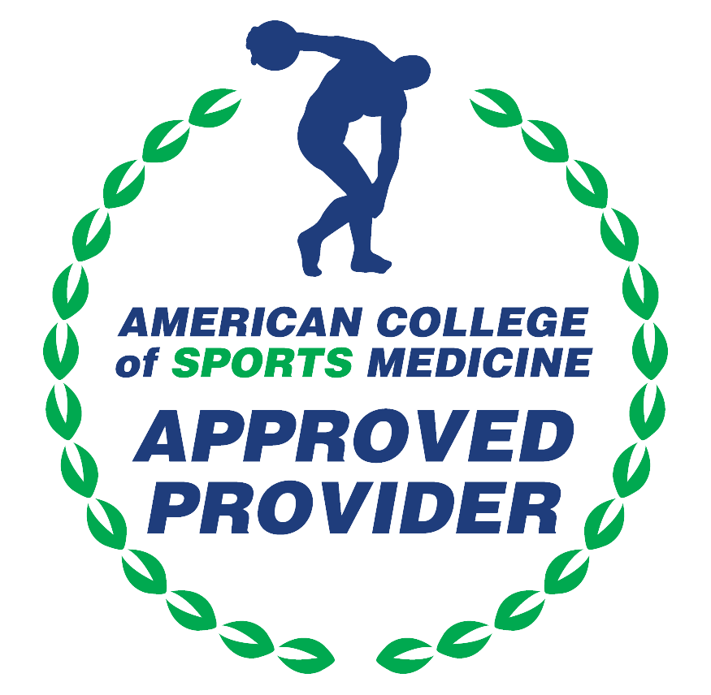

American Medical Association (AMA)
AdventHealth Orlando is accredited by the Florida Medical Association (FMA) to provide continuing medical education for physicians.
AdventHealth Orlando designates this Live Activity for a maximum of 16.25 AMA PRA Category 1 Credit(s)™. Physicians should claim only the credit commensurate with the extent of their participation in the activity.







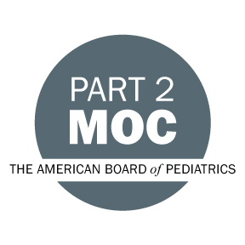

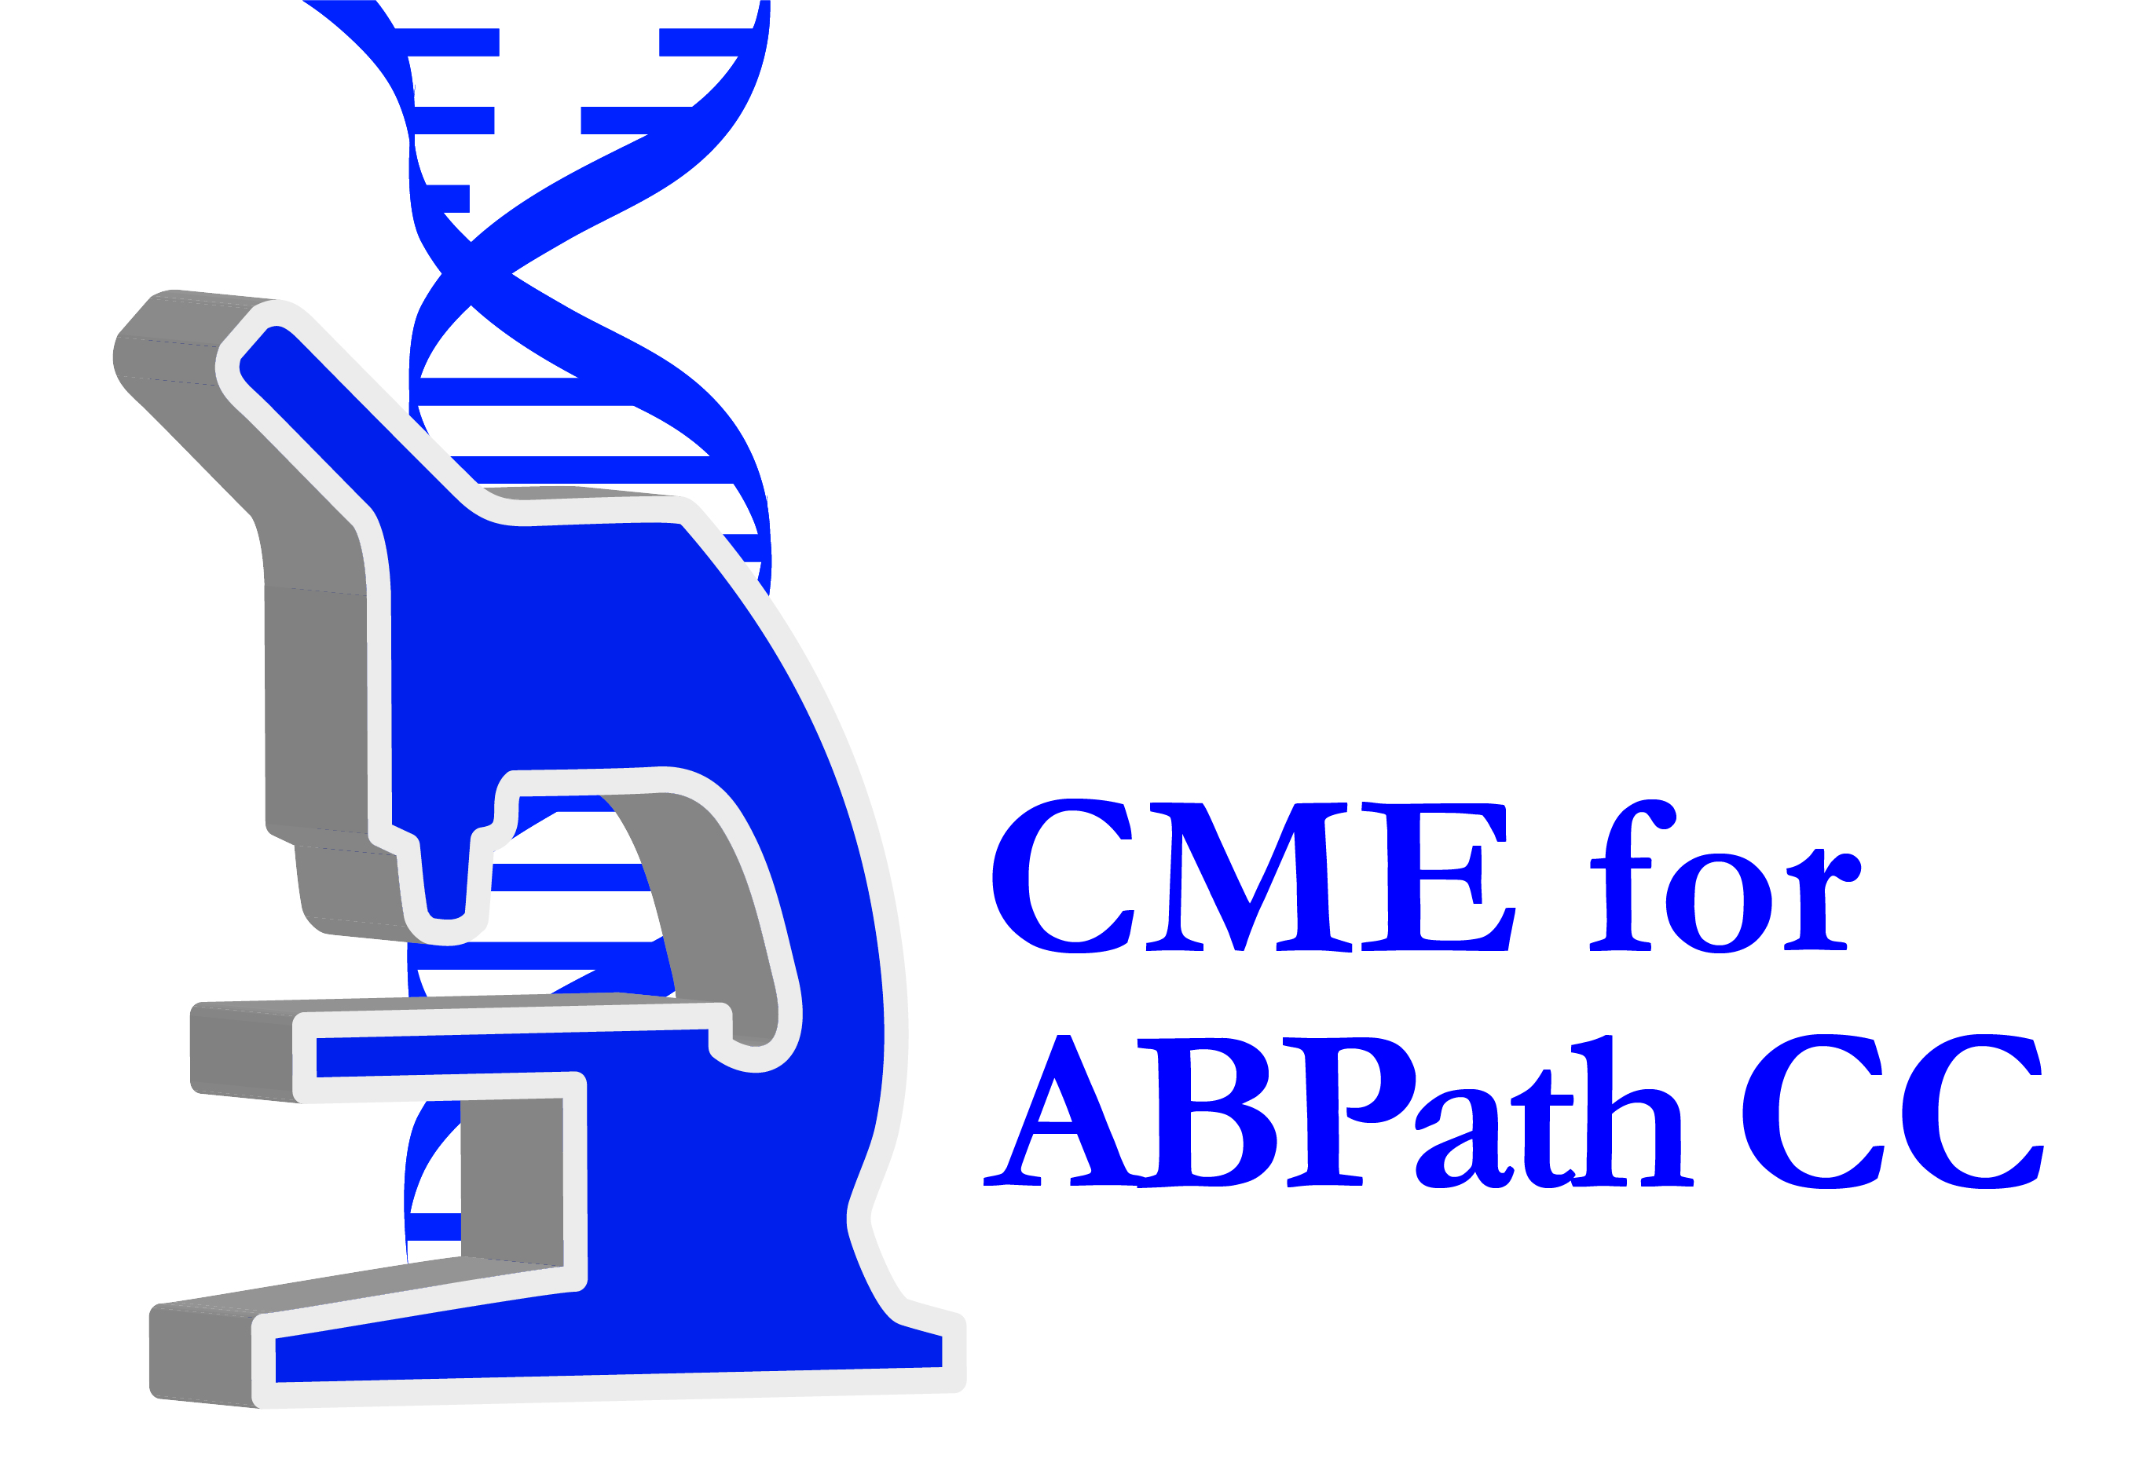

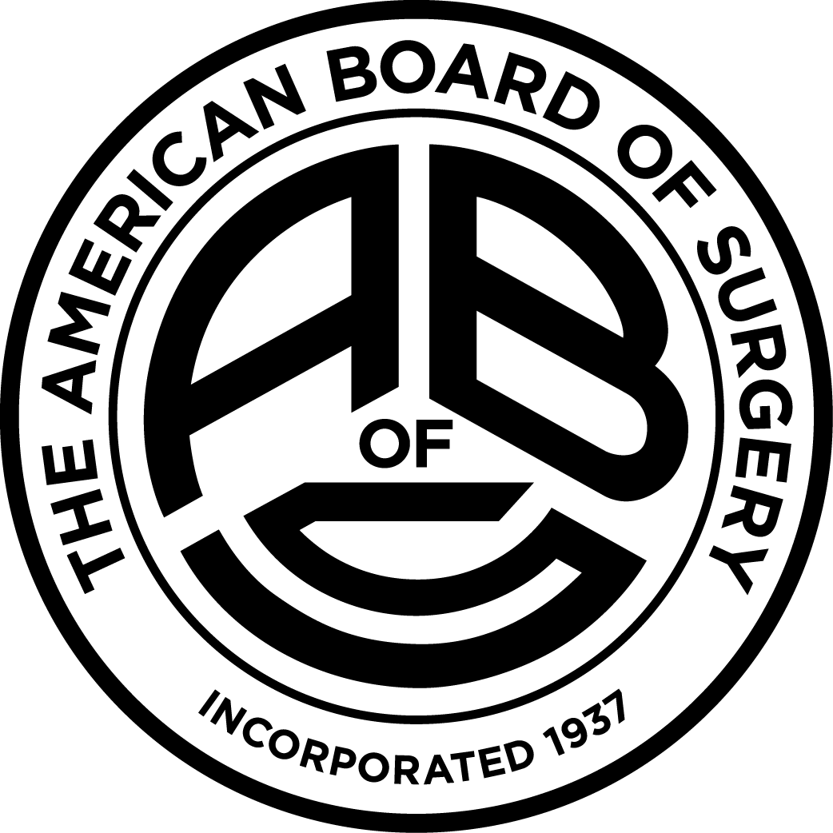

Other Healthcare Professionals
Other healthcare professionals who participate in this activity may submit their statement of participation to their appropriate accrediting organizations or state boards for consideration of credit. Participants are responsible for determining whether this activity meets the requirements for acceptable continuing education.
Disclosures:
AdventHealth Orlando CME adheres to the ACCME’s Standards for Integrity and Independence in Accredited Continuing Education. Any individuals in a position to control the content of a CE activity, including faculty, planners, reviewers or others are required to disclose all relevant financial relationships with ineligible entities (commercial interests). All relevant conflicts of interest have been mitigated prior to the commencement of the activity.

The planners and faculty of this series have disclosed the following financial relationship(s) with ineligible companies/commercial interests:
Name of individual | Individual's role in activity | Nature of Relationship(s) / Name of Ineligible Company(s)
Mildred Abodakpi, BSN | Faculty | Nothing to disclose - 04/30/2026
Arti Bhavsar, Unknown | Faculty | Nothing to disclose - 09/02/2026
Lisa E. Campbell, MHA, RN | Faculty | Nothing to disclose - 09/23/2025
Jason Cirolia, PT | Faculty | Nothing to disclose - 04/29/2026
Allan Frankel, MD | Faculty
Makeba Garrison, DMin, MDiv, MEd | Faculty
David A. George, BSN, RN, CCRN-K | Faculty | Nothing to disclose - 04/28/2026
Ashleigh A. Gonzalez, MSN, RN, RNC, CPPS | Nurse Planner | Nothing to disclose - 11/21/2025
Mike A. Irwin, BSIE | Faculty | Nothing to disclose - 11/13/2025
Erica K. Jacques, MBA | Faculty | Nothing to disclose - 04/29/2026
Jaclyn Jeffries, PharmD, CPh, CPPS | Faculty | Membership on Advisory Committees or Review Panels, Board Membership, etc.-Baxter International, Inc. (Relationship has ended)|Paid consultant-ICU Medical - 11/06/2025
Kimberly Jentsch, PhD | Faculty | Nothing to disclose - 12/09/2025
Jeffrey C. Kuhlman, MD, MPH, CPPS | Faculty | Nothing to disclose - 04/28/2026
Rachel Lassel, RN | Faculty
Charlene A. LePane, DO | Faculty
Bryan M. Lin, MS | Faculty | Nothing to disclose - 09/02/2026
Omayra L. Mansfield, MD, MHA, FACEP | Faculty | Nothing to disclose - 09/01/2026
J. Mike Nunn, MBA | Faculty
Stacy W. Prince, JD | Faculty | Nothing to disclose - 08/06/2026
Amy Reichard, LPN | Activity Coordinator | Nothing to disclose - 09/01/2026
Camille Rey, MSN, BSN, RN | Faculty | Nothing to disclose - 08/24/2026
Robert Roncska, DBA | Faculty | Nothing to disclose - 09/02/2026
William R. Scharf, MD | Faculty | Non-Clinical Exception
Korey M. Settle, MSN | Faculty | Nothing to disclose - 04/28/2026
John Summers, MBA | Faculty | Nothing to disclose - 09/02/2026
Mary Jo Thompson, MBA, RN, CPHRM, CPPS, FASHRM | Faculty
Teresa M. Tomlinson, MSN, RN | Course Director, Faculty | Nothing to disclose - 09/02/2026
Dunia Villaverde, Unknown | Faculty | Non-Clinical Exception

