So You Want to Go on a Medical Mission?
Date/Time: | 7/8/2026 12:30:00 PM | Activity ID: | 22487
Location: | Werner Auditorium
Topic | Medical Missions: Are You Ready to Make a Difference?  Join us as we uncover what it really takes to be an effective medical mission volunteer. Learn how to get involved, avoid common pitfalls, and contribute in meaningful ways that support sustainable, community-centered care.  Objective(s): 1 Identify systems, structures and processes in global health programs that increase potential for medical errors and adverse events. 2 Identify resources and strategies needed to facilitate patient safety in global health programs. 3 Describe culturally sensitive partnership strategies that promote human dignity and facilitate health development. 4 Locate resources to educate themselves prior to attending medical missions.  Location: Werner Auditorium  Specialties: Pediatrics  Coordinator: Jessica Pena  Faculty Disclosures:  Stacy Ann McConkey, MD (Nothing to disclose - 07/01/2026)  Download Handout
Objectives:
After this activity, the participant will be able to:

1 Identify systems, structures and processes in global health programs that increase potential for medical errors and adverse events.
2 Identify resources and strategies needed to facilitate patient safety in global health programs.
3 Describe culturally sensitive partnership strategies that promote human dignity and facilitate health development.
4 Locate resources to educate themselves prior to attending medical missions.
Accreditation:


ACPE Universal Activity Number (UAN): Technician:

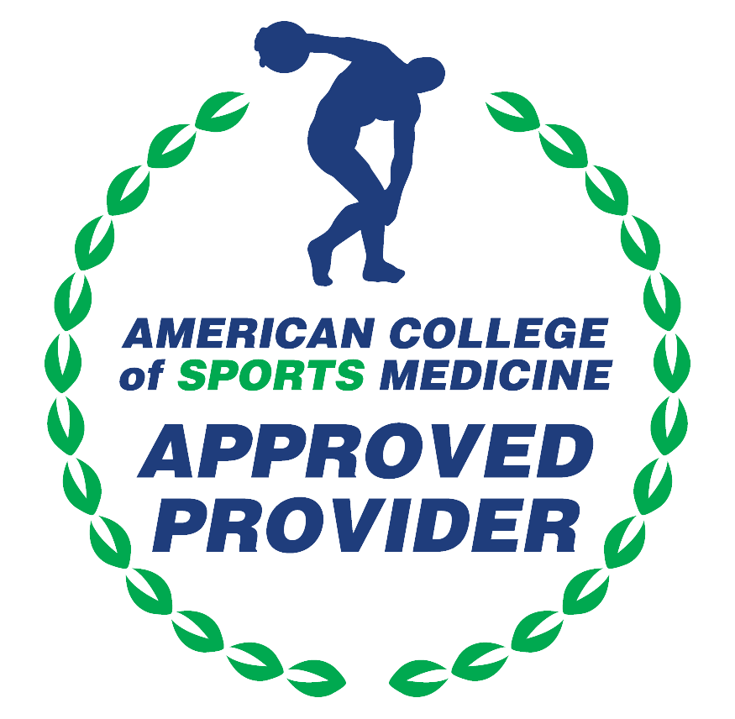

American Medical Association (AMA)
AdventHealth Orlando is accredited by the Florida Medical Association (FMA) to provide continuing medical education for physicians.
AdventHealth Orlando designates this Live Activity for a maximum of 1.00 AMA PRA Category 1 Credit(s)™. Physicians should only claim the credit commensurate with the extent of their participation in the activity.







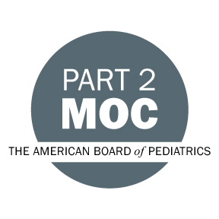

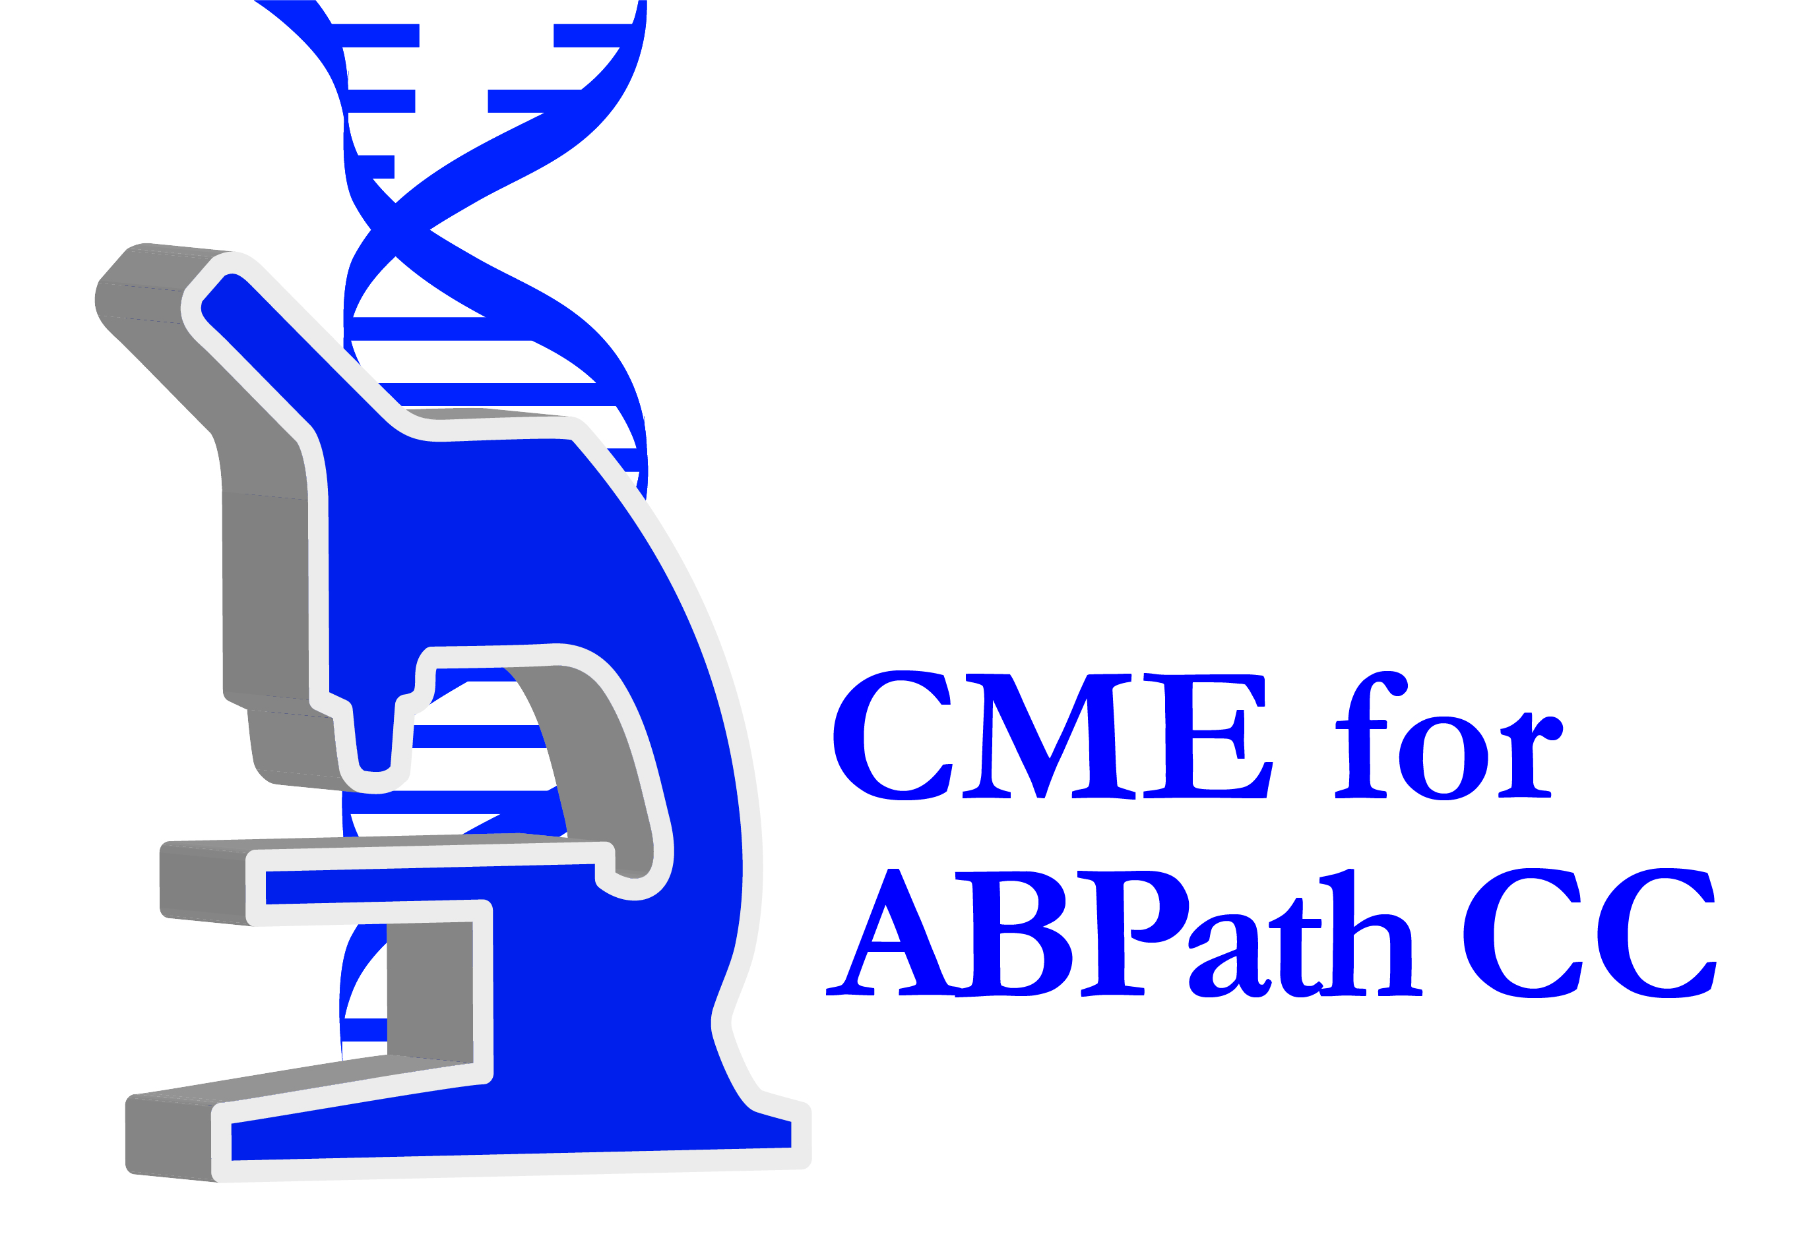

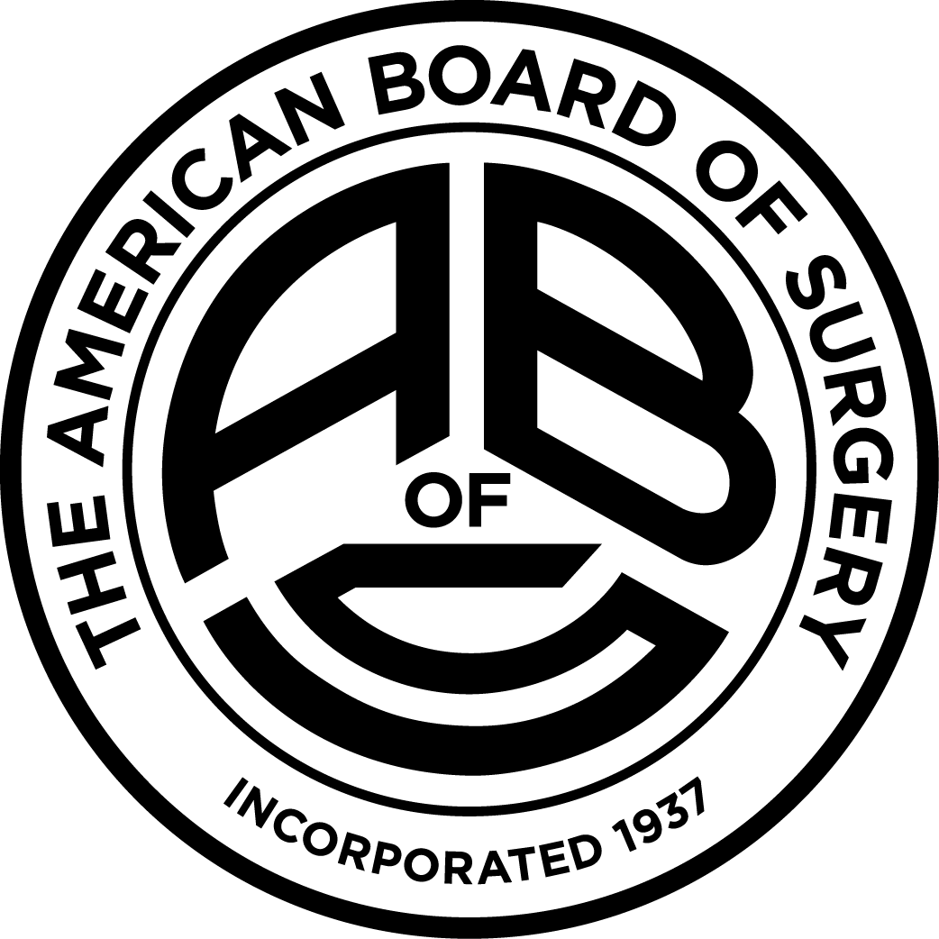

Other Healthcare Professionals
Other healthcare professionals who participate in this activity may submit their statement of participation to their appropriate accrediting organizations or state boards for consideration of credit. Participants are responsible for determining whether this activity meets the requirements for acceptable continuing education.
Disclosures:
AdventHealth Orlando CME adheres to the ACCME’s Standards for Integrity and Independence in Accredited Continuing Education. Any individuals in a position to control the content of a CE activity, including faculty, planners, reviewers or others are required to disclose all relevant financial relationships with ineligible entities (commercial interests). All relevant conflicts of interest have been mitigated prior to the commencement of the activity.

The planners and faculty of this series have disclosed the following financial relationship(s) with ineligible companies/commercial interests:
Name of individual | Individual's role in activity | Nature of Relationship(s) / Name of Ineligible Company(s)
Shani H. Cunningham, DO | Course Director
Stacy Ann McConkey, MD | Course Director, Faculty | Nothing to disclose - 07/01/2026
Nancy Ramos, BA | Activity Coordinator | Nothing to disclose - 10/13/2025

