2026 Grand Rounds: Neurology (CFD)
Date/Time: | 1/9/2026 12:00:00 PM | Activity ID: | 22475
Location: | Virtual Meeting
Topic | Discover the future of neurology at the 2026 Neurology Grand Rounds designed for the entire neurology community. This series brings together experts and innovators to foster collaboration of neurological disorders and treatments. Experience the most comprehensive program yet, featuring diverse presentations and interactive sessions that tackle today’s biggest challenges and highlight emerging trends. Don’t miss your chance to connect, learn, and shape the future of neurological care!
Objectives:
After this activity, the participant will be able to:

1 Integration with Clinical Practice: Enhance practical application of theoretical knowledge through case studies, practical demonstrations, and collaborative projects.
2 Ongoing Education: Ensure healthcare professionals are updated on the latest advancements in disease pathology, diagnosis, and management, incorporating emerging research, innovative diagnostic tools, and evidence-based treatment protocols.
3 Case-Based Learning: Improve competency and treatment of complex diseases through detailed analysis of real-life scenarios, encouraging critical thinking, problem-solving, peer discussion, and mentorship.
4 Curriculum Customization: Address specific educational needs through a thorough root cause analysis, ensuring the learning experience is highly relevant and targeted for long-term improvements in clinical practice and patient outcomes.
Accreditation:


ACPE Universal Activity Number (UAN): Technician:

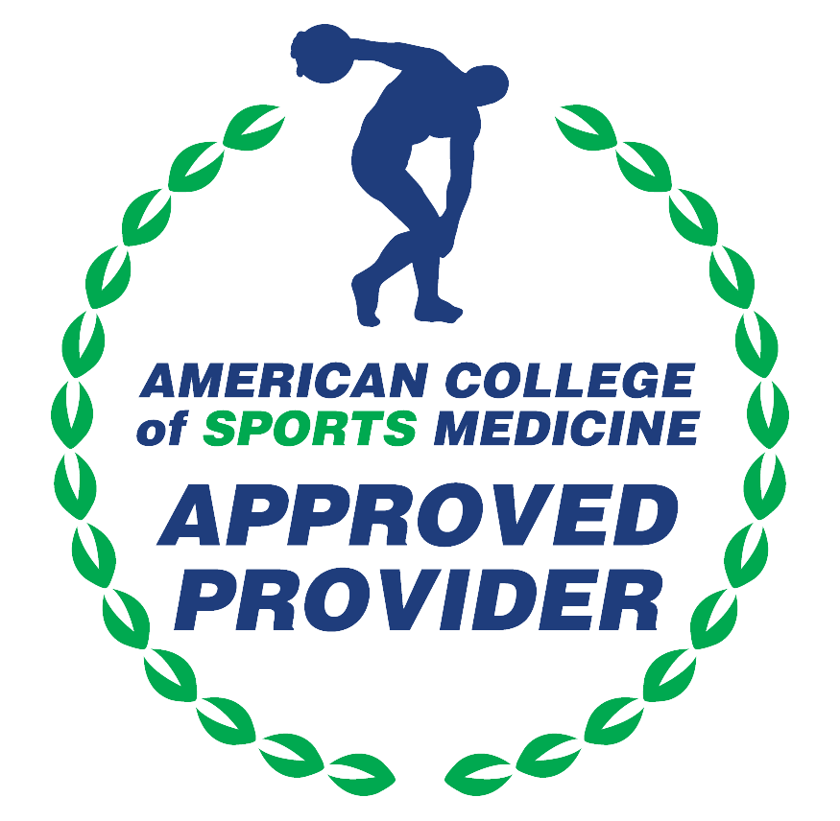

American Medical Association (AMA)
AdventHealth Orlando is accredited by the Florida Medical Association (FMA) to provide continuing medical education for physicians.
AdventHealth Orlando designates this Live Activity for a maximum of 1.00 AMA PRA Category 1 Credit(s)™. Physicians should only claim the credit commensurate with the extent of their participation in the activity.







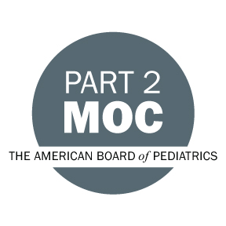

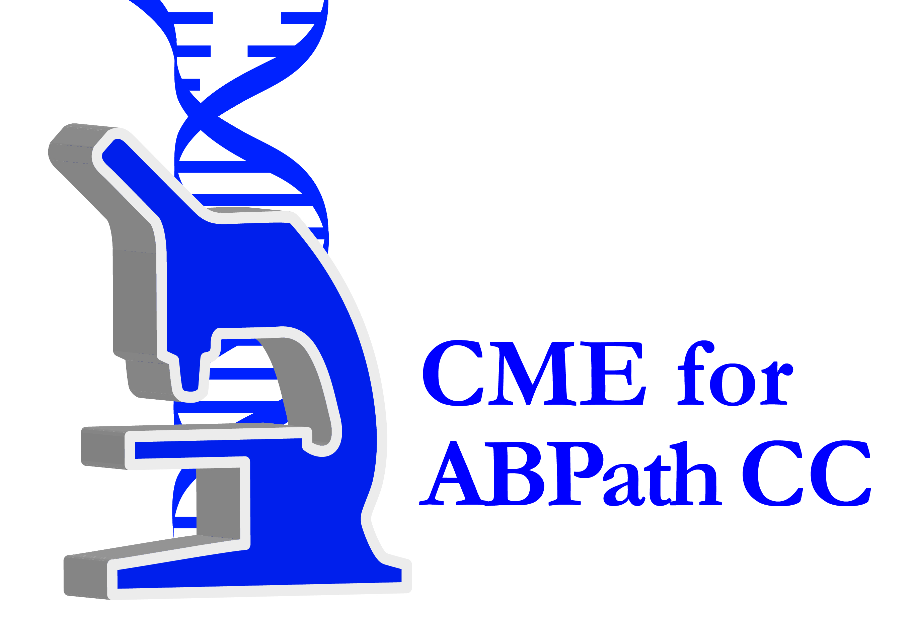

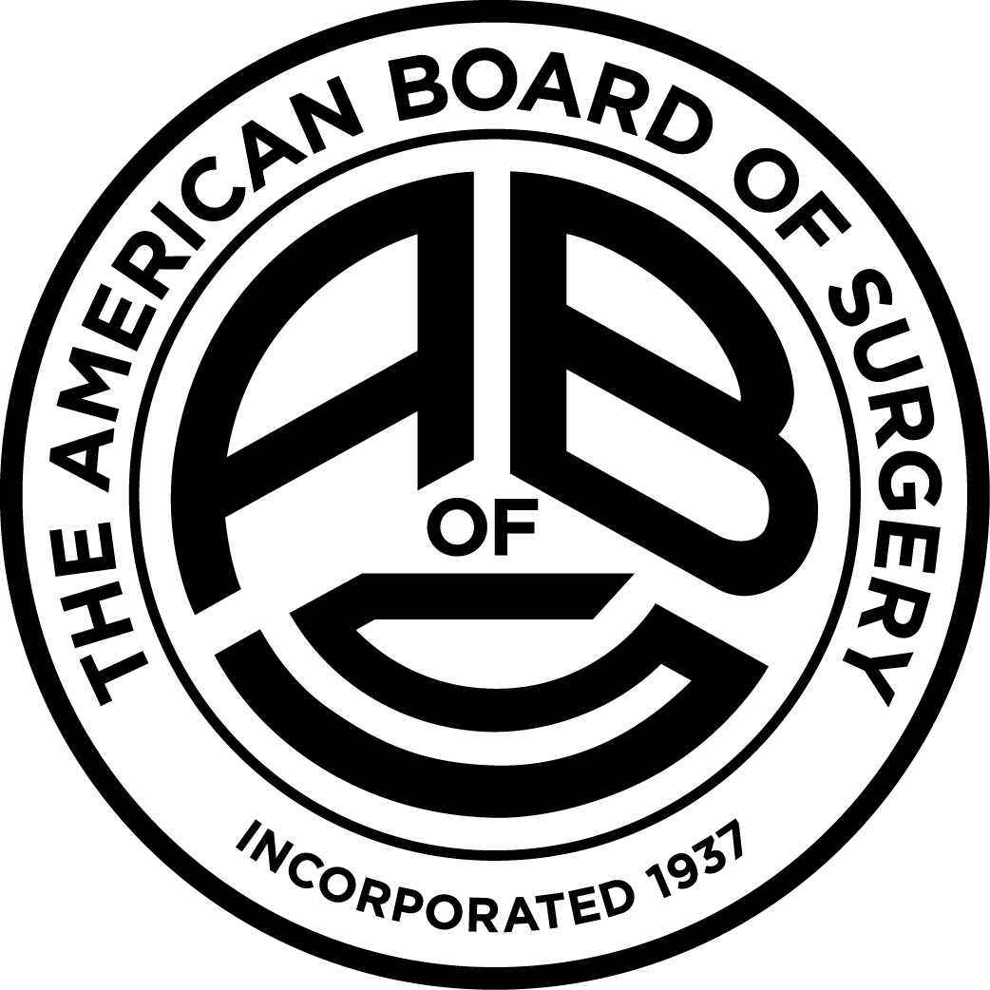

Other Healthcare Professionals
Other healthcare professionals who participate in this activity may submit their statement of participation to their appropriate accrediting organizations or state boards for consideration of credit. Participants are responsible for determining whether this activity meets the requirements for acceptable continuing education.
Disclosures:
AdventHealth Orlando CME adheres to the ACCME’s Standards for Integrity and Independence in Accredited Continuing Education. Any individuals in a position to control the content of a CE activity, including faculty, planners, reviewers or others are required to disclose all relevant financial relationships with ineligible entities (commercial interests). All relevant conflicts of interest have been mitigated prior to the commencement of the activity.

The planners and faculty of this series have disclosed the following financial relationship(s) with ineligible companies/commercial interests:
Name of individual | Individual's role in activity | Nature of Relationship(s) / Name of Ineligible Company(s)
Anwar Ahmed, MD | Course Director | Nothing to disclose - 01/25/2025
Gayle A. Shepherd, BSN | Nurse Planner | Nothing to disclose - 12/02/2025

