2025 Mastering Brain Death Determination: Evidence-Based Strategies for Complex Cases (IEM)
Date/Time: | 12/11/2025 8:00:00 AM | Activity ID: | 22398
Location: | Online
Topic | Join this engaging CME session to sharpen your skills in one of the most critical areas of clinical practice—brain death determination. Explore the evidence-based approach to prerequisites, neurologic and apnea testing, and ancillary studies. Through real-world case scenarios, you’ll gain practical insights to confidently navigate challenging situations while ensuring strict adherence to institutional and national guidelines. Don’t miss this opportunity to strengthen your expertise and improve patient care.
Objectives:
After this activity, the participant will be able to:

1 Identify the physiologic and clinical prerequisites required before initiating brain death testing.
2 Describe the step-by-step process of the neurologic examination used to confirm absence of brain function.
3 Perform and interpret the apnea test in accordance with national and institutional guidelines.
4 Recognize conditions that can confound brain death assessment, such as hypothermia, drug intoxication, or metabolic derangements.
Accreditation:


ACPE Universal Activity Number (UAN): Technician:

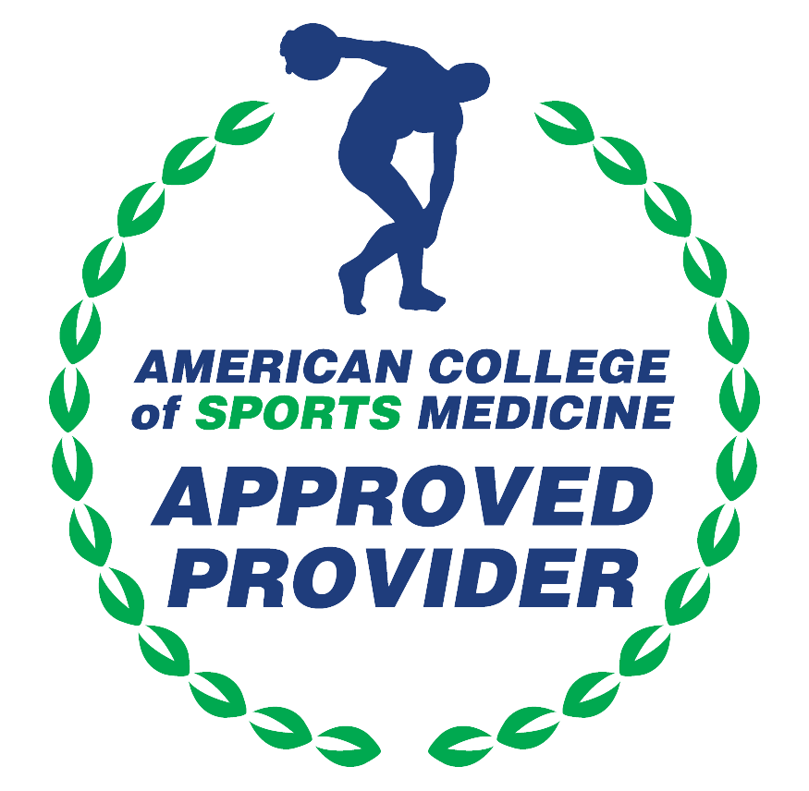

American Medical Association (AMA)
AdventHealth Orlando is accredited by the Florida Medical Association (FMA) to provide continuing medical education for physicians.
AdventHealth Orlando designates this Enduring Material for a maximum of 1.00 AMA PRA Category 1 Credit(s)™. Physicians should only claim the credit commensurate with the extent of their participation in the activity.

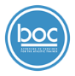



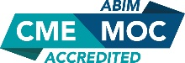

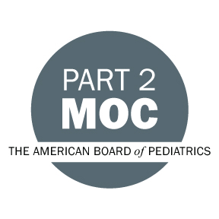

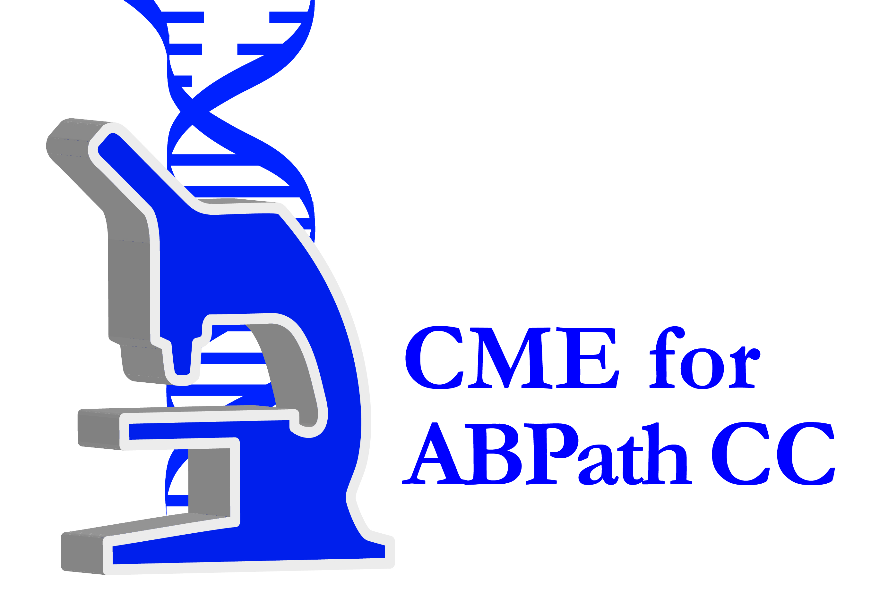

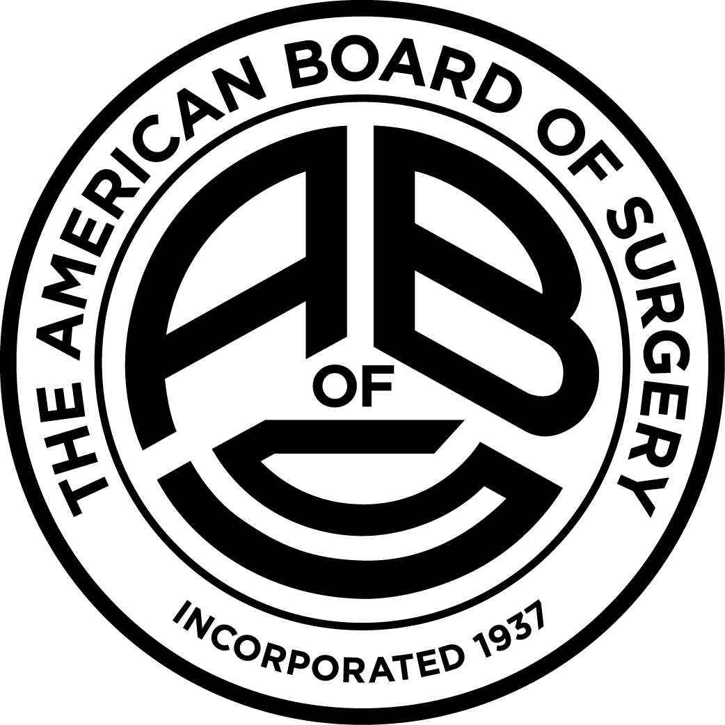

Other Healthcare Professionals
Other healthcare professionals who participate in this activity may submit their statement of participation to their appropriate accrediting organizations or state boards for consideration of credit. Participants are responsible for determining whether this activity meets the requirements for acceptable continuing education.
Disclosures:
AdventHealth Orlando CME adheres to the ACCME’s Standards for Integrity and Independence in Accredited Continuing Education. Any individuals in a position to control the content of a CE activity, including faculty, planners, reviewers or others are required to disclose all relevant financial relationships with ineligible entities (commercial interests). All relevant conflicts of interest have been mitigated prior to the commencement of the activity.

The planners and faculty of this series have disclosed the following financial relationship(s) with ineligible companies/commercial interests:
Name of individual | Individual's role in activity | Nature of Relationship(s) / Name of Ineligible Company(s)
Bobby N. Nibhanupudy, MD | Co-Director | Nothing to disclose - 09/02/2025
Amay Parikh, MD, MBA, FACP | Co-Director, Faculty | Nothing to disclose - 11/07/2025

