2026 AHCI: Contemporary Lung Cancer Treatment (EFD)
Date/Time: | 8/5/2026 5:30:00 PM | Activity ID: | 22390
Location: | Oceanside Country Club
Topic | Join us for engaging discussions that dive into the rapidly evolving landscape of lung cancer therapeutics. Gain invaluable insights into current best practices and future directions, including biomarker testing, immunotherapy, targeted therapy, and both surgical and non-surgical options. Expert-led discussions will explore the latest advancements and practical strategies to optimize patient outcomes. Don’t miss this opportunity to stay ahead in lung cancer care and bring cutting-edge knowledge back to your practice!
Objectives:
After this activity, the participant will be able to:

1 Analyze emerging scientific and clinical data to inform evidence-based management strategies in lung cancer care.
2 Evaluate evidence-based guidelines and clinical research to support appropriate clinical decision-making.
3 Apply multidisciplinary approaches to develop individualized treatment plans that improve patient outcomes in lung cancer.
Accreditation:


ACPE Universal Activity Number (UAN): Technician:

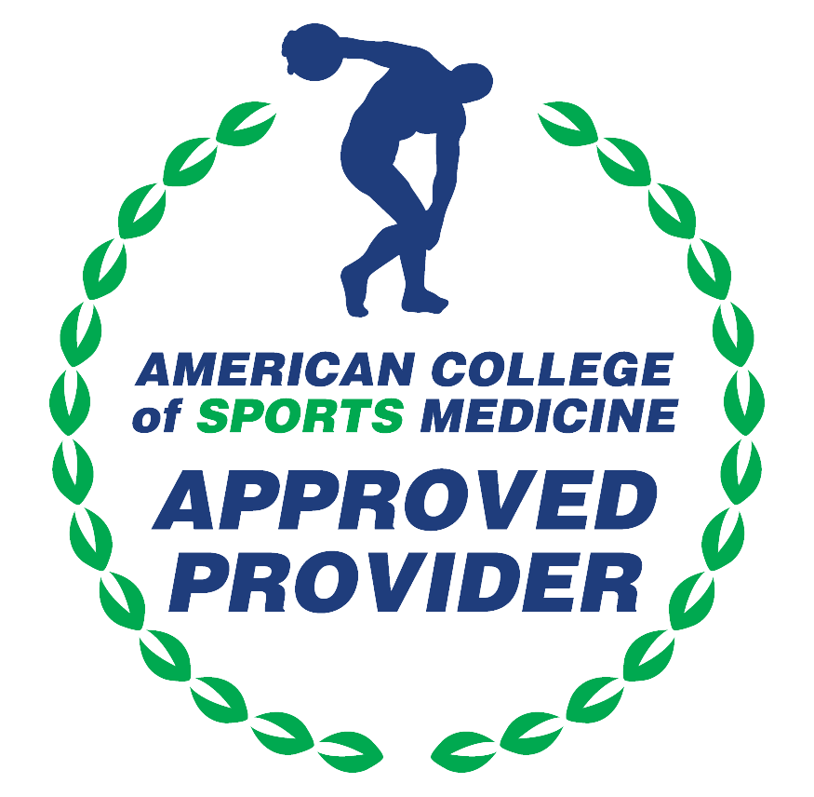

American Medical Association (AMA)
AdventHealth Orlando is accredited by the Florida Medical Association (FMA) to provide continuing medical education for physicians.
AdventHealth Orlando designates this Live Activity for a maximum of 2.00 AMA PRA Category 1 Credit(s)™. Physicians should only claim the credit commensurate with the extent of their participation in the activity.







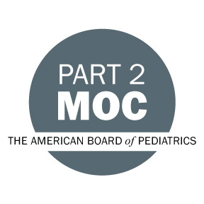

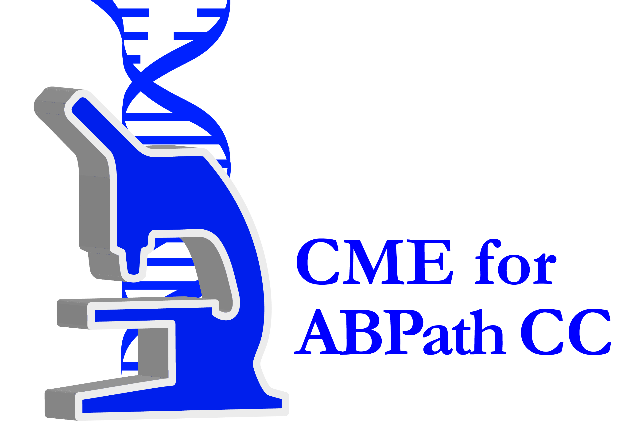



Other Healthcare Professionals
Other healthcare professionals who participate in this activity may submit their statement of participation to their appropriate accrediting organizations or state boards for consideration of credit. Participants are responsible for determining whether this activity meets the requirements for acceptable continuing education.
Disclosures:
AdventHealth Orlando CME adheres to the ACCME’s Standards for Integrity and Independence in Accredited Continuing Education. Any individuals in a position to control the content of a CE activity, including faculty, planners, reviewers or others are required to disclose all relevant financial relationships with ineligible entities (commercial interests). All relevant conflicts of interest have been mitigated prior to the commencement of the activity.

The planners and faculty of this series have disclosed the following financial relationship(s) with ineligible companies/commercial interests:
Name of individual | Individual's role in activity | Nature of Relationship(s) / Name of Ineligible Company(s)
Samuel H. Crayton, MD, PhD | Faculty
Nicolette R. Huntley, MD | Faculty | Nothing to disclose - 11/20/2025
Sandra D. Jennings, MSN | Faculty, Nurse Planner | Nothing to disclose - 12/02/2025
Andrea Katz, MD | Faculty
Patrick T. Mangonon, MD | Course Director, Faculty | Nothing to disclose - 05/09/2026
Alvaro Martin Menjivar, MD | Faculty
Abby Richards, BA | Activity Administrator | Nothing to disclose - 10/28/2025
Kevin Chad Schaeffer, MS, RN, FACHE | Nurse Planner | Nothing to disclose - 12/02/2025

