2026 Grand Rounds: Head and Neck (CFD)
Date/Time: | 2/9/2026 5:00:00 PM | Activity ID: | 21944
Location: | Virtual Meeting
Topic | Join us for an engaging and educational session where leading experts in otolaryngology, oncology, radiology, and surgery come together to explore the latest advancements in head and neck care. This Grand Rounds will feature dynamic case presentations, evidence-based discussions, and multidisciplinary insights into the diagnosis, treatment, and management of complex head and neck conditions with time at the end to ask questions.
Objectives:
After this activity, the participant will be able to:

1 Facilitate open bidirectional communication among team members to discuss challenges with patient care.
2 Discuss emerging technologies and updated clinical guidelines to deliver holistic patient care that includes psychiatric and psychological considerations.
Accreditation:


ACPE Universal Activity Number (UAN): Technician:

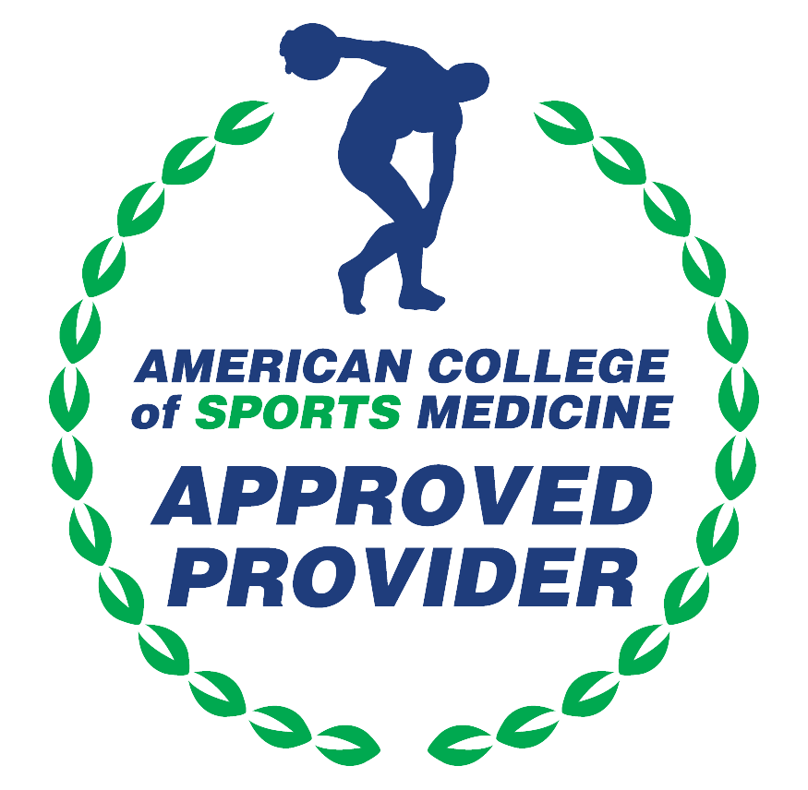

American Medical Association (AMA)
AdventHealth Orlando is accredited by the Florida Medical Association (FMA) to provide continuing medical education for physicians.
AdventHealth Orlando designates this Live Activity for a maximum of 1.00 AMA PRA Category 1 Credit(s)™. Physicians should only claim the credit commensurate with the extent of their participation in the activity.







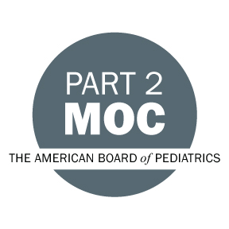

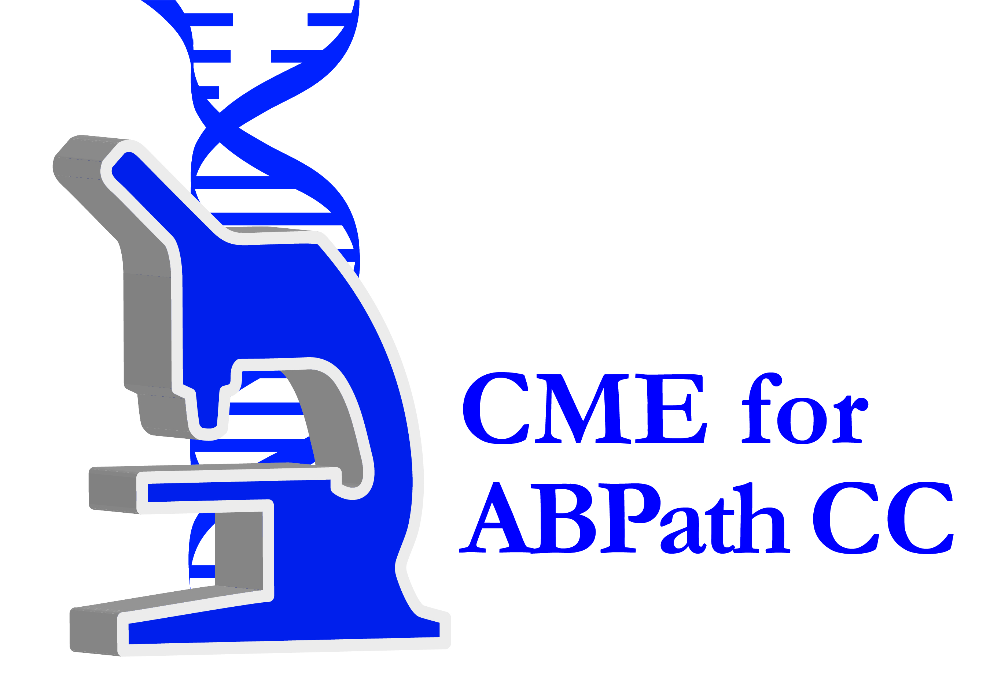

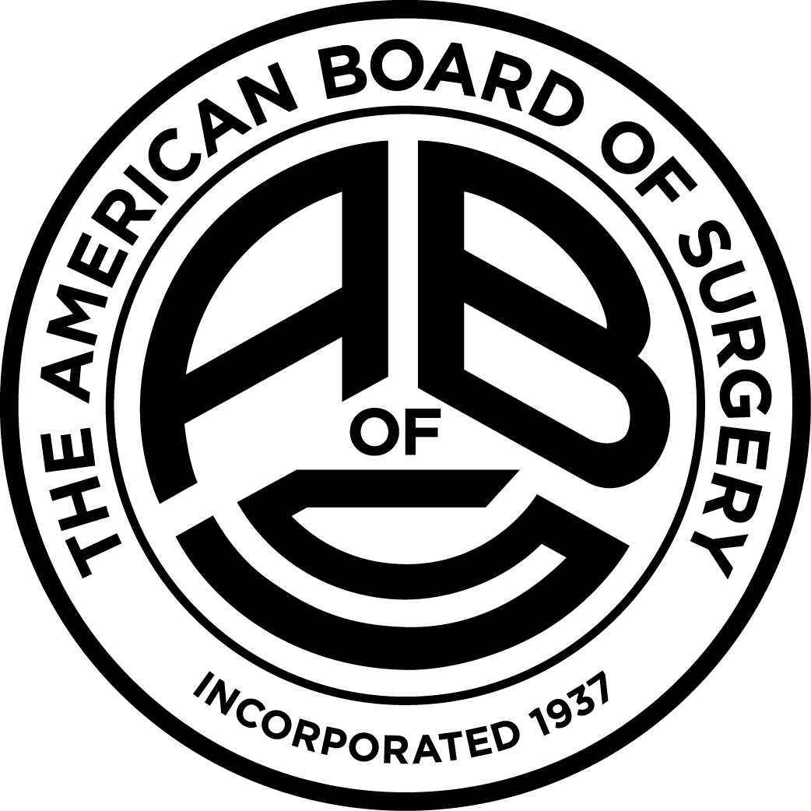

Other Healthcare Professionals
Other healthcare professionals who participate in this activity may submit their statement of participation to their appropriate accrediting organizations or state boards for consideration of credit. Participants are responsible for determining whether this activity meets the requirements for acceptable continuing education.
Disclosures:
AdventHealth Orlando CME adheres to the ACCME’s Standards for Integrity and Independence in Accredited Continuing Education. Any individuals in a position to control the content of a CE activity, including faculty, planners, reviewers or others are required to disclose all relevant financial relationships with ineligible entities (commercial interests). All relevant conflicts of interest have been mitigated prior to the commencement of the activity.

The planners and faculty of this series have disclosed the following financial relationship(s) with ineligible companies/commercial interests:
Name of individual | Individual's role in activity | Nature of Relationship(s) / Name of Ineligible Company(s)
Jeffery Scott Magnuson, MD, FACS | Co-Director | Consulting Fee-Sutter Medical Technologies USA - 07/02/2025
Uthman A. Alamoudi, MD | Course Director | Nothing to disclose - 08/27/2025

