2025 AHPN Clinical Care Pathways: Chronic Kidney Disease (PI)
Date/Time: | 3/6/2025 12:00:00 AM | Activity ID: | 21510
Location: | Performance Improvement
Topic | Chronic Kidney Disease (CKD) affects over 35 million people in the US. This video explains the AdventHealth PHN Clinical Care Pathways process and offers primary care providers dealing with ambulatory chronic diseases an opportunity to improve patient care.  This discussion reviews the guidelines of the National Kidney Foundation and KDIGO (Kidney Disease Improving Global Outcomes) for CKD, providing essential information to ensure their approach to CKD management aligns with the best practices and current standards.
Objectives:
After this activity, the participant will be able to:

1 Increase awareness and implement comprehensive screening plans to identify CKD in its early stages.
2 Develop evidence-based guidelines to apply consistent management of CKD at the ambulatory setting.
Accreditation:


ACPE Universal Activity Number (UAN): Technician:



American Medical Association (AMA)
AdventHealth Orlando is accredited by the Florida Medical Association (FMA) to provide continuing medical education for physicians.
AdventHealth Orlando designates this PI CME activity for a maximum of 20.00 AMA PRA Category 1 Credit(s)™. Physicians should only claim the credit commensurate with the extent of their participation in the activity.







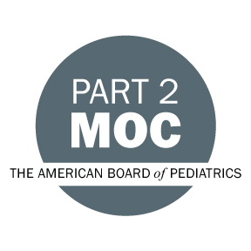





Other Healthcare Professionals
Other healthcare professionals who participate in this activity may submit their statement of participation to their appropriate accrediting organizations or state boards for consideration of credit. Participants are responsible for determining whether this activity meets the requirements for acceptable continuing education.
Disclosures:
AdventHealth Orlando CME adheres to the ACCME&rsquo;s Standards for Integrity and Independence in Accredited Continuing Education. Any individuals in a position to control the content of a CE activity, including faculty, planners, reviewers or others are required to disclose all relevant financial relationships with ineligible entities (commercial interests). All relevant conflicts of interest have been mitigated prior to the commencement of the activity.

The planners and faculty of this series have disclosed the following financial relationship(s) with ineligible companies/commercial interests:
Name of individual | Individual's role in activity | Nature of Relationship(s) / Name of Ineligible Company(s)
Hezi Cohen, MD | Co-Director, Faculty
Thomas W Diller, MD, MMM | Co-Director
Shara Hutchinson, PharmD | Pharmacy Planner
Romeena T. Martinez, DO | Planning Committee
Daniel J. Tambunan, MD | Planning Committee

