2024 Heart, Lung, and Vascular Conference
Date/Time: | 4/5/2024 7:00:00 AM | Activity ID: | 18294
Location: | AdventHealth Nicholson Center, 404 Celebration
Topic | This conference will help improve/ build service lines, provide key updates in the heart lung & vascular world, discuss 2030 goals and future innovation.
Objectives:
After this activity, the participant will be able to:

1 HEART: Explore practical applications of CV Genetics and Genomics in real-world scenarios.
2 HEART: Discuss the patient journey from diagnostics to procedure.
3 LUNG: Gain insights into creating a lung nodule program and utilizing a multi-disciplinary approach.
4 LUNG: Acquire knowledge and skills in lung cancer and thoracic oncology techniques.
5 VASCULAR: Learn best practices in Vascular care, with a focus on quality care and vascular health for women.
6 VASCULAR: Review best practices for preventing amputation.
Accreditation:


ACPE Universal Activity Number (UAN): Technician:

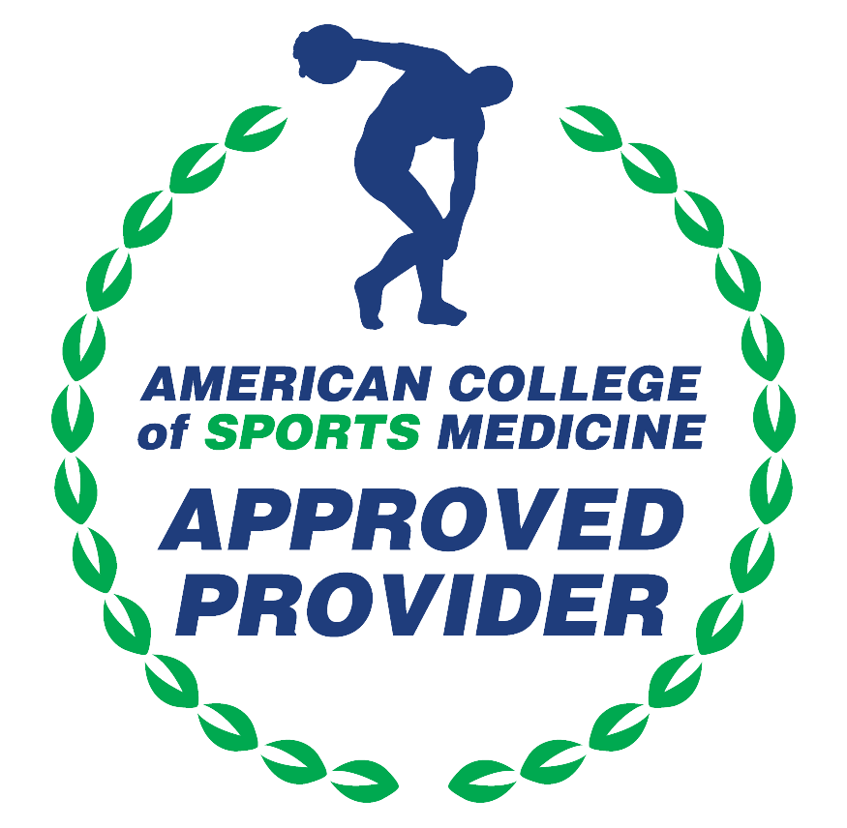

American Medical Association (AMA)
AdventHealth Orlando is accredited by the Florida Medical Association (FMA) to provide continuing medical education for physicians.
AdventHealth Orlando designates this Live Activity for a maximum of 5.00 AMA PRA Category 1 Credit(s)™. Physicians should only claim the credit commensurate with the extent of their participation in the activity.







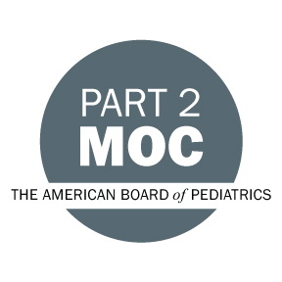

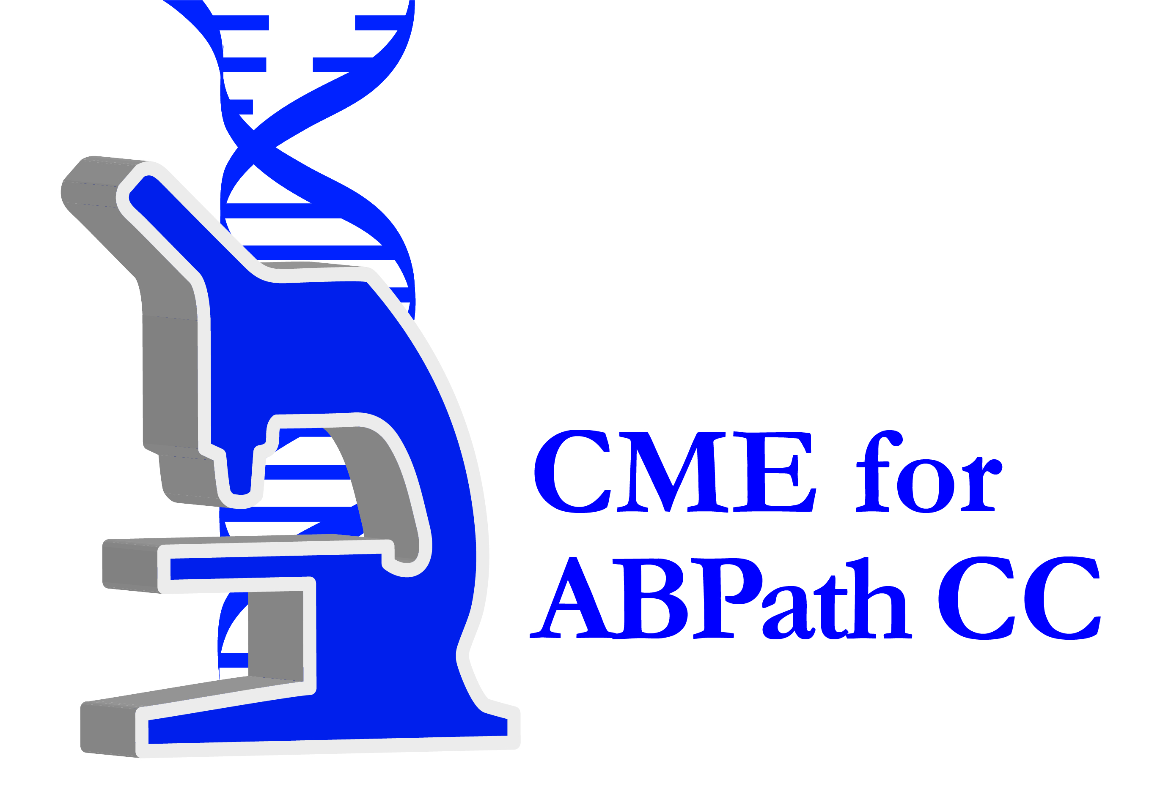



Other Healthcare Professionals
Other healthcare professionals who participate in this activity may submit their statement of participation to their appropriate accrediting organizations or state boards for consideration of credit. Participants are responsible for determining whether this activity meets the requirements for acceptable continuing education.
Disclosures:
AdventHealth Orlando CME adheres to the ACCME&rsquo;s Standards for Integrity and Independence in Accredited Continuing Education. Any individuals in a position to control the content of a CE activity, including faculty, planners, reviewers or others are required to disclose all relevant financial relationships with ineligible entities (commercial interests). All relevant conflicts of interest have been mitigated prior to the commencement of the activity.

The planners and faculty of this series have disclosed the following financial relationship(s) with ineligible companies/commercial interests:
Name of individual | Individual's role in activity | Nature of Relationship(s) / Name of Ineligible Company(s)
Kevin D. Accola, MD | Faculty | Consulting Fee-Edwards Lifesciences LLC - 01/04/2024
Nipun Arora, MD, FACC, FSCAI | Faculty | Consulting Fee-Abbott Laboratories (Relationship has ended) - 03/05/2024
Rohit Bhatheja, MD, MBA, FACC, FSCAI | Faculty | Speakers Bureau-Abbott Vascular|Speakers Bureau-Boehringer Ingelheim Vetmedica GmbH|Consulting Fee-Boston Scientific Corporation|Speakers Bureau-Amgen|Speakers Bureau-Cardiovascular Systems, Inc (Relationship has ended)|Speakers Bureau-Penumbra - 04/04/2024
Francisco J. Calimano, MD, FCCP | Faculty | Speakers Bureau-GlaxoSmithKline|Grant or research support-Vertex - 04/03/2024
Gary W. Chmielewski, MD, FACS | Faculty | Nothing to disclose - 01/15/2024
Marcelo C. DaSilva, MD | Faculty | Honoraria-AstraZeneca - 01/10/2024
Robert Duane Davis Jr., MD | Faculty | Nothing to disclose - 12/28/2023
Lara M. Ervin, BSN | Faculty | Nothing to disclose - 01/17/2024
Colleen B. Gaughan, MD | Faculty | Nothing to disclose - 12/05/2023
Duncan A. Grodack, Unknown | Faculty | Nothing to disclose - 03/22/2024
Patricia A. Guerrero, MD, CPE, FACC, FASPC | Faculty | Nothing to disclose - 07/05/2023
Marcos S. Hazday, MD | Faculty | Nothing to disclose - 04/04/2024
Ralph P. Ierardi, MD, FACS | Faculty | Nothing to disclose - 12/28/2023
Jeffrey Maguire, English | Faculty | Nothing to disclose - 03/18/2024
Francois Nolte, Other | Faculty
George J. Palmer III, MD | Faculty
Sotero Peralta, MD | Faculty | Nothing to disclose - 01/04/2024
Mark E. Ranson, MD, FACS | Faculty | Nothing to disclose - 01/13/2024
Jonathan R. Schroeder, DO | Faculty | Executive-StoRx, LLC (Relationship has ended) - 10/25/2023
Rajesh A. Shah, MD | Faculty | Nothing to disclose - 01/14/2024
Usman R. Siddiqui, MD | Faculty | Consulting Fee-Abbott Laboratories|Consulting Fee-Medtronic, Inc.|Paid consultant-Biotronik, Inc.|Paid consultant-Bristol-Myers Squibb|Advisor-GE Healthcare Bio-Sciences - 03/05/2024
David G. Varnagy, MD, FACS | Faculty | Consulting Fee-Merit - 01/17/2024
Andrija Vidic, DO | Faculty | Advisor-caredx (Relationship has ended) - 01/04/2024
Thomas F. Walsh IV, MD, FACC | Faculty | Nothing to disclose - 01/11/2024
Gordon B. Wesley, DBA, FACHE, RT (R) | Course Director, Faculty | Advisor-Boston Scientific Corporation|Advisor-G Medical Innovations - 02/16/2024
Rachel E. Wilson, MD | Faculty | Nothing to disclose - 03/05/2024
Alan R. Wladis, MD | Faculty | Nothing to disclose - 01/10/2024
Ahmad Zeeshan, MD, FACS | Faculty | Nothing to disclose - 03/03/2024

