2023 Endobariatric Symposium and Suturing Masterclass
Date/Time: | 10/6/2023 7:00:00 AM | Activity ID: | 18073
Location: | AdventHealth Nicholson Center
Topic | The primary goal of the course is to provide a comprehensive, one-day, individualized hands-on workshop on current and emerging techniques in endobariatrics. The hands-on sessions will be taught by experienced world-renowned experts in the field. The low participant-to-faculty ratio of 2-3:1 will ensure a one-of-a-kind immersive workshop.
Objectives:
After this activity, the participant will be able to:

1 Learn how to build a successful endoscopic bariatric program at your institution.
1 Learn about currently available endoscopic procedures for weight loss.
2 Explain current and incoming available intragastric devices and techniques.
3 Discuss endoscopic metabolic therapies that target the small bowel.
4 Review the management of adverse events of endoscopic bariatric procedures.
6 Acquire endoscopic skills needed to confidently perform endoscopic weight loss procedures.
Accreditation:





American Medical Association (AMA)
AdventHealth Orlando is accredited by the Florida Medical Association (FMA) to provide continuing medical education for physicians.
AdventHealth Orlando designates this Live Activity for a maximum of 8.00 AMA PRA Category 1 Credit(s)™. Physicians should claim only the credit commensurate with the extent of their participation in the activity.







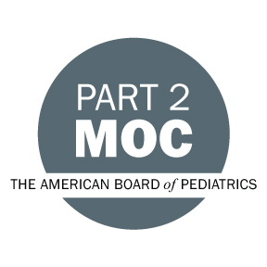

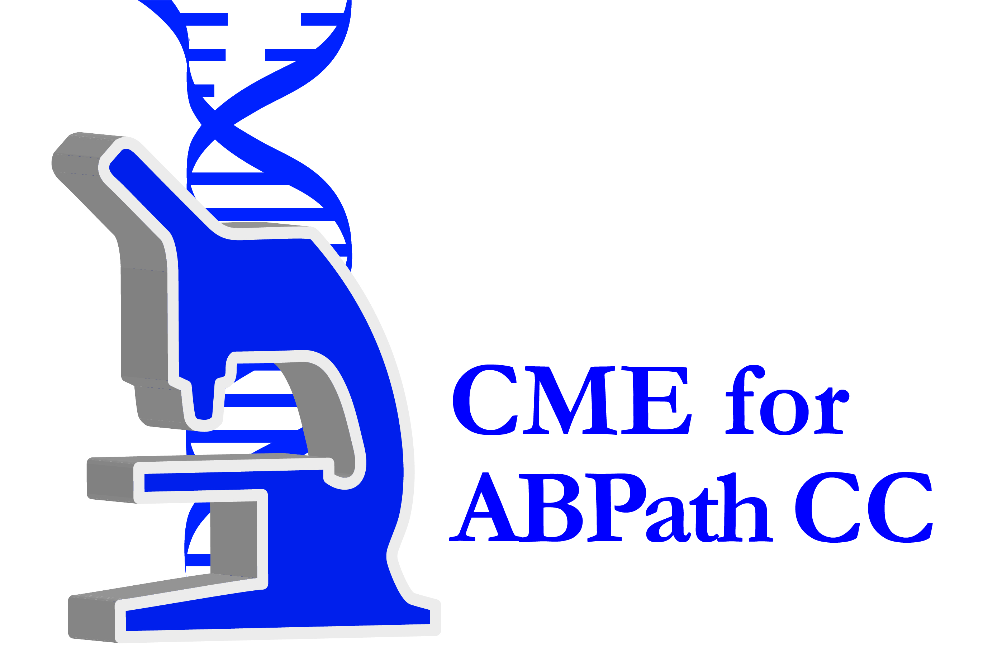



Other Healthcare Professionals
Other healthcare professionals who participate in this activity may submit their statement of participation to their appropriate accrediting organizations or state boards for consideration of credit. Participants are responsible for determining whether this activity meets the requirements for acceptable continuing education.
Disclosures:
AdventHealth Orlando CME adheres to the ACCME’s Standards for Integrity and Independence in Accredited Continuing Education. Any individuals in a position to control the content of a CE activity, including faculty, planners, reviewers or others are required to disclose all relevant financial relationships with ineligible entities (commercial interests). All relevant conflicts of interest have been mitigated prior to the commencement of the activity.

The planners and faculty of this series have disclosed the following financial relationship(s) with ineligible companies/commercial interests:
Name of individual | Individual's role in activity | Nature of Relationship(s) / Name of Ineligible Company(s)
Mustafa A. Arain, MD | Organizing Faculty | Consulting Fee-Boston Scientific Corporation|Consulting Fee-Medtronic, Inc.|Consulting Fee-Cook Endoscopy - 06/30/2023
Austin Chiang, MD | Faculty | Employment-Medtronic, Inc. - 08/15/2023
Natalie D. Cosgrove, MD | Organizing Faculty | Consulting Fee-Boston Scientific Corporation|Consulting Fee-Olympus - 04/24/2023
Manoel Galvao Neto, MD | Faculty | Consulting Fee-Galvao Companies|Other: Consultant, proctor, and Scientific Advisory Board member -GI Dynamics|Other: Faculty in training courses, consultant and proctor-Apollo Endosurgery|Other: consultant and proctor -USGI|Other: PI for study-Spatz|Membership on Advisory Committees or Review Panels, Board Membership, etc.-Nitinotes|Membership on Advisory Committees or Review Panels, Board Membership, etc.-Keyron|Speakers Bureau-erbe|Other: Faculty in training courses and consultant -Alacer Biomedica - 06/07/2023
Muhammad K. Hasan, MD | Course Director, Faculty | Consulting Fee-Olympus America|Consulting Fee-Micro-Tech Endoscopy|Consulting Fee-Boston Scientific Corporation - 04/13/2023
Deepanshu Jain, MD | Faculty, Organizing Faculty | Nothing to disclose - 04/24/2023
Kambiz S. Kadkhodayan, MD | Course Director, Faculty | Nothing to disclose - 01/04/2023
Steven Shamah, MD | Faculty | Nothing to disclose - 04/18/2023
Sanmeet Singh, MD | Organizing Faculty | Nothing to disclose - 04/25/2023
Artur V. Viana, MD | Organizing Faculty | Nothing to disclose - 04/25/2023
Dennis J. Yang, MD, FACG, FASGE, AGAF | Organizing Faculty | Consulting Fee-Olympus|Consulting Fee-Boston Scientific Corporation|Consulting Fee-Fuji|Consulting Fee-Medtronic, Inc.|Consulting Fee-MicroTech|Consulting Fee-Neptune Medical|Consulting Fee-3D Matrix|Grant or research support-MicroTech|Grant or research support-3D Matrix - 04/22/2023

