Genitourinary Journal Club
Date/Time: | 11/2/2023 6:00:00 PM | Activity ID: | 17882
Location:
Topic | AHCI Oncology Journal Club occurs quarterly on topics optimizing the management of cancer patients. Each program will review and discuss evidence-based guidelines, new clinical/scientific data, and treatment strategies to improve patient outcomes while embracing live multidisciplinary engagement.
Objectives:
After this activity, the participant will be able to:

1 Critique recent journal articles with peers highlighting emerging scientific and clinical data, novel treatment strategies, and other advances related to oncology specialties and sub-specialties to optimize management of care.
2 Discuss the impact of literature relating to evidence-based guidelines, clinical research/trials, and precision medicine as appropriate.
3 Integrate recent and pertinent knowledge gained from literature in practice within oncology..
Accreditation:



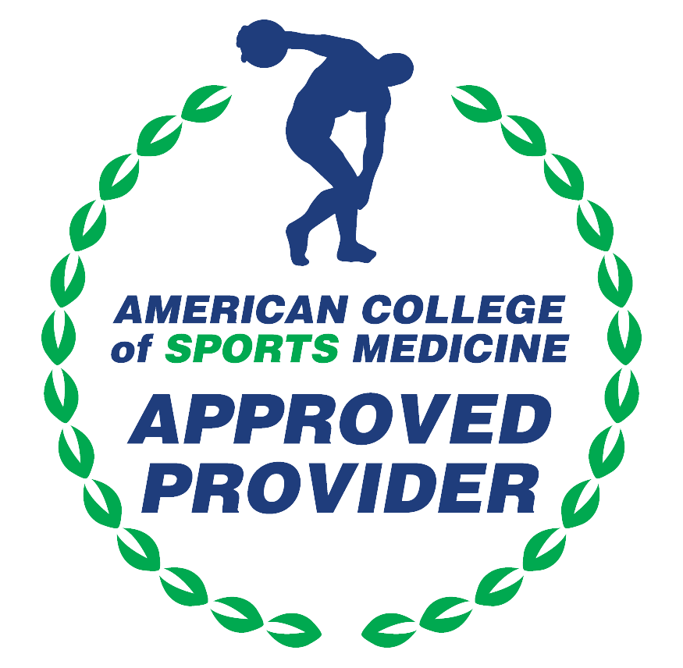

American Medical Association (AMA)
AdventHealth Orlando is accredited by the Florida Medical Association (FMA) to provide continuing medical education for physicians.
AdventHealth Orlando designates this Live Activity for a maximum of 1.50 AMA PRA Category 1 Credit(s)™. Physicians should claim only the credit commensurate with the extent of their participation in the activity.







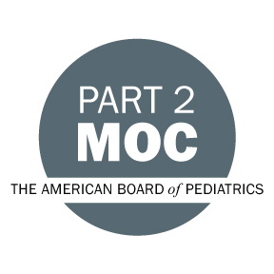

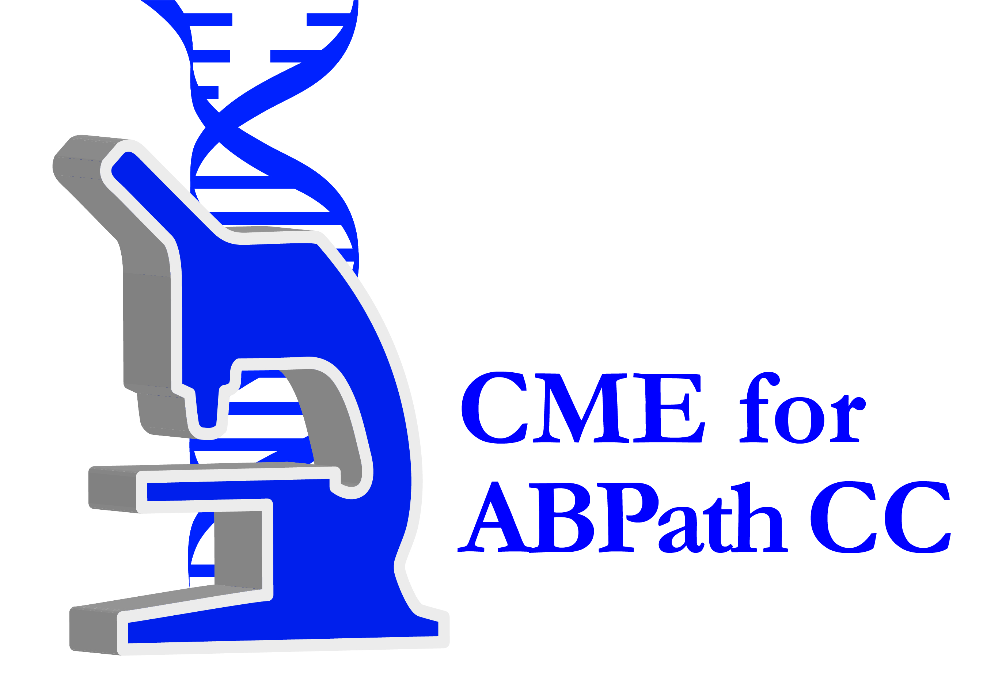

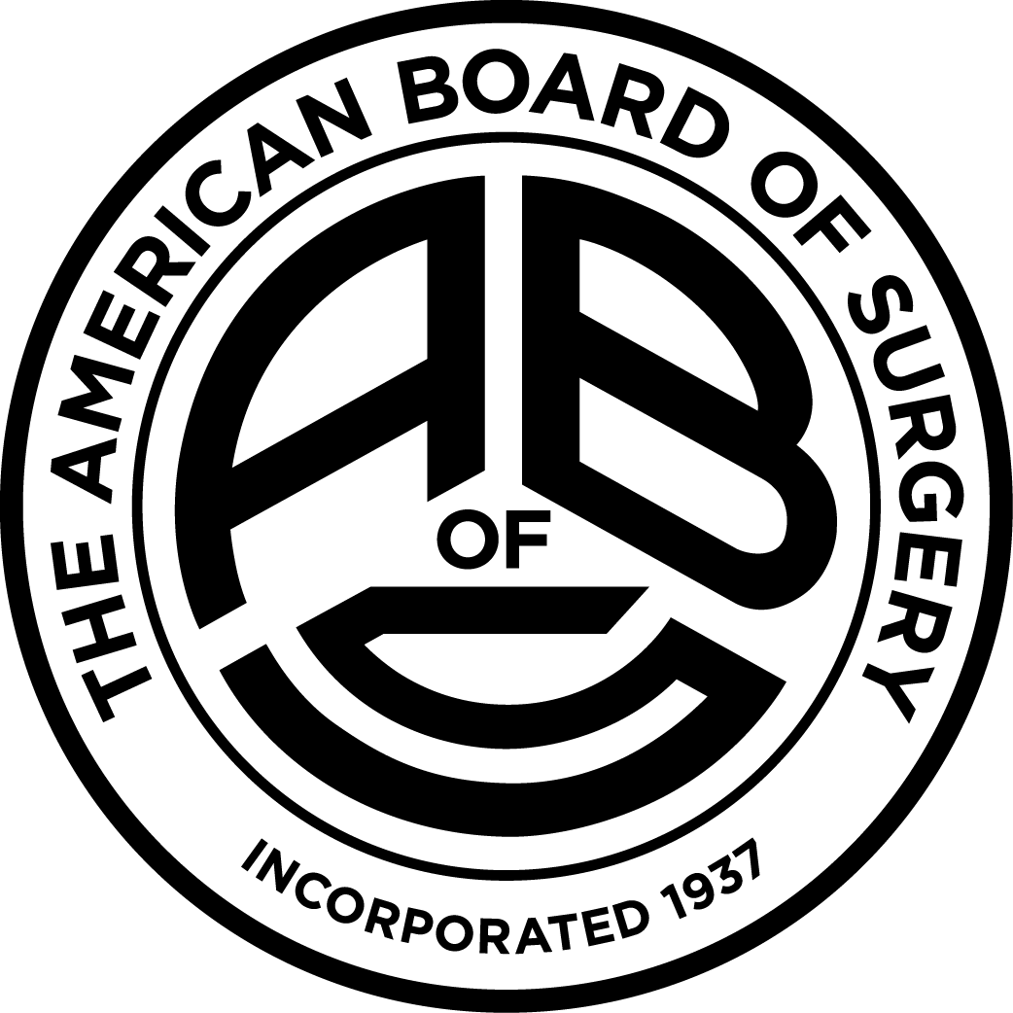

Other Healthcare Professionals
Other healthcare professionals who participate in this activity may submit their statement of participation to their appropriate accrediting organizations or state boards for consideration of credit. Participants are responsible for determining whether this activity meets the requirements for acceptable continuing education.
Disclosures:
AdventHealth Orlando CME adheres to the ACCME’s Standards for Integrity and Independence in Accredited Continuing Education. Any individuals in a position to control the content of a CE activity, including faculty, planners, reviewers or others are required to disclose all relevant financial relationships with ineligible entities (commercial interests). All relevant conflicts of interest have been mitigated prior to the commencement of the activity.

The planners and faculty of this series have disclosed the following financial relationship(s) with ineligible companies/commercial interests:
Name of individual | Individual's role in activity | Nature of Relationship(s) / Name of Ineligible Company(s)
Carlos A. Alemany, MD | Co-Director, Faculty | Nothing to disclose - 04/08/2023
Amanda L. Bowman, HS | Activity Coordinator | Nothing to disclose - 04/17/2023
Danielle Bromley, BS, LSSYB | Other Planning Committee Member | Nothing to disclose - 11/30/2022
Natalie A. Dorta, MS, LSSGB, CCMP | Activity Administrator | Nothing to disclose - 08/15/2023
Bruce H. Haughey, MD, MBChB, MS, FRACS, FACS | Co-Director, Faculty | Honoraria-Lumenis (Relationship has ended) - 04/12/2023
Tarek M. Mekhail, MD, MSc, FRCSI, FRCSEd | Co-Director, Faculty | Speakers Bureau-AstraZeneca|Speakers Bureau-Bristol-Myers Squibb|Consulting Fee-Daiichi Sankyo|Speakers Bureau-Eli Lilly and Company|Speakers Bureau-Genentech, Inc.|Speakers Bureau-Merck and Company, Inc.|Speakers Bureau-Novartis AG|Speakers Bureau-Sanofi-Aventis|Speakers Bureau-Takeda Pharmaceuticals, Inc. - 12/07/2022
Vipul R. Patel, MD, FACS | Co-Director, Faculty | Nothing to disclose - 03/21/2023
Mark A. Socinski, MD | Course Director | Membership on Advisory Committees or Review Panels, Board Membership, etc.-Genentech, Inc.|Membership on Advisory Committees or Review Panels, Board Membership, etc.-AstraZeneca|Speakers Bureau-Bristol-Myers Squib Aventis|Honoraria-Bayer Corporation|Speakers Bureau-Guardant Health|Membership on Advisory Committees or Review Panels, Board Membership, etc.-Merck and Company, Inc.|Membership on Advisory Committees or Review Panels, Board Membership, etc.-Roche|Membership on Advisory Committees or Review Panels, Board Membership, etc.-Eli Lilly and Company|Membership on Advisory Committees or Review Panels, Board Membership, etc.-Mirati Therapeutics|Membership on Advisory Committees or Review Panels, Board Membership, etc.-Janssen Oncology|Speakers Bureau-Jazz Pharmaceuticals|Honoraria-Gritstone Bio|Honoraria-Novartis|Speakers Bureau-Sanofi Regeneron|Honoraria-Gilead|Membership on Advisory Committees or Review Panels, Board Membership, etc.-Spectrum Pharmaceuticals|Speakers Bureau-G1 Therapeutics|Honoraria-Coherus Biosciences|Honoraria-Arcus Biosciences|Speakers Bureau-Takeda Pharmaceuticals, Inc.|Grant or research support-Daiichi Sankyo|Speakers Bureau-BluePrint Medicines|Honoraria-GlaxoSmithKline|Speakers Bureau-Amgen - 03/09/2023

