2022 Orlando Colorectal Congress LIVE! Didactic
Date/Time: | 11/10/2022 7:00:00 AM | Activity ID: | 16501
Location: | Loews Portofino Bay Hotel at Universal Orlando™
Topic | This course was developed to provide annual in-depth exposure and review up to date techniques for rectal cancer surgery, introduce surgeon and attendee's to robotic colorectal surgery, discuss the importance of multidisciplinary treatment in rectal cancer, cover new trends in enhanced recovery pathways (ERAS), surgery for pelvic floor disorders, and the evolving treatment of inflammatory bowel disease to improve hospital care quality.  2- day didactic course with 1- day APP track.
Objectives:
After this activity, the participant will be able to:

1 Discuss the comprehensive education in surgical and endoscopic management of colorectal disease.
2 Describe emerging techniques and options for the management of colorectal disease.
3 Integrate different expert approaches to challenging colorectal cases.
4 Review state-of-the-art management of common clinical scenarios.
Accreditation:



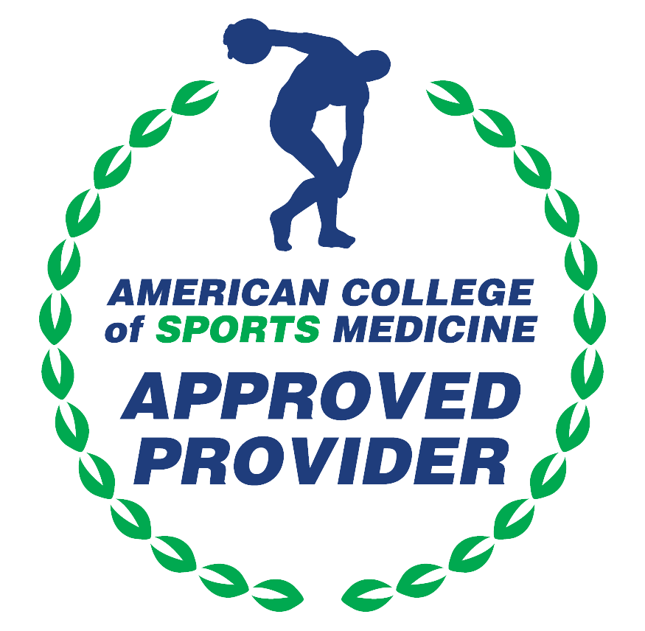

American Medical Association (AMA)
AdventHealth Orlando is accredited by the Florida Medical Association (FMA) to provide continuing medical education for physicians.
AdventHealth Orlando designates this Live Activity for a maximum of 12.25 AMA PRA Category 1 Credit(s)™. Physicians should claim only the credit commensurate with the extent of their participation in the activity.







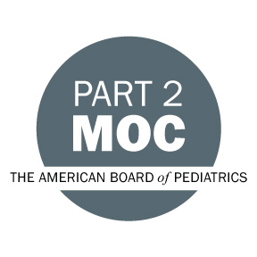

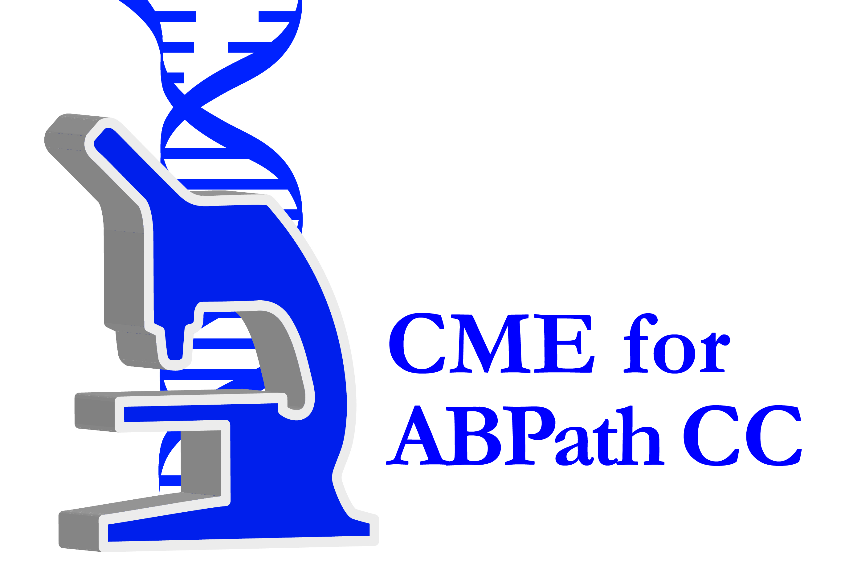

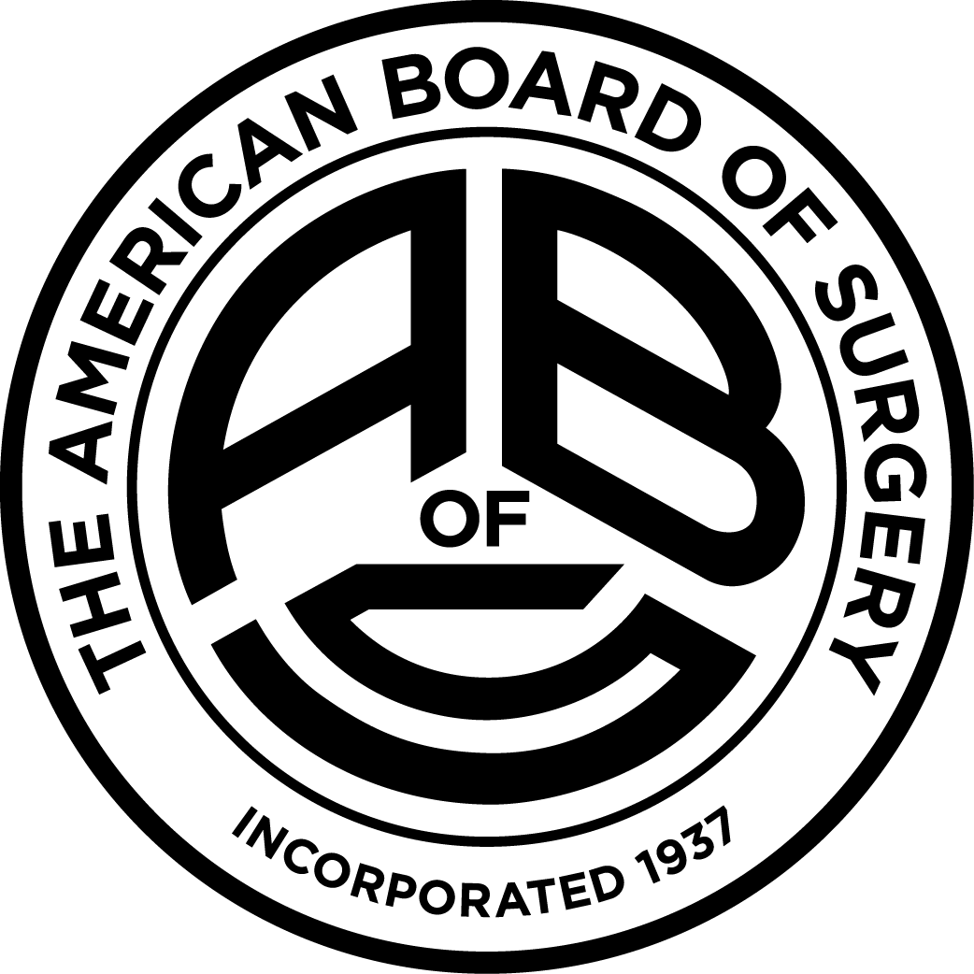
American Board of Surgery Continuing Certification
Successful completion of this CME activity, which includes participation in the evaluation component, enables the learner to earn 12.00 credit towards the CME requirement of the American Board of Surgery’s Continuous Certification program. It is the CME activity provider’s responsibility to submit learner completion information to ACCME for the purpose of granting ABS credit.

Other Healthcare Professionals
Other healthcare professionals who participate in this activity may submit their statement of participation to their appropriate accrediting organizations or state boards for consideration of credit. Participants are responsible for determining whether this activity meets the requirements for acceptable continuing education.
Disclosures:
AdventHealth Orlando CME adheres to the ACCME’s Standards for Integrity and Independence in Accredited Continuing Education. Any individuals in a position to control the content of a CE activity, including faculty, planners, reviewers or others are required to disclose all relevant financial relationships with ineligible entities (commercial interests). All relevant conflicts of interest have been mitigated prior to the commencement of the activity.

The planners and faculty of this series have disclosed the following financial relationship(s) with ineligible companies/commercial interests:
Name of individual | Individual's role in activity | Nature of Relationship(s) / Name of Ineligible Company(s)
Matthew R. Albert, MD, FACS, FASCRS | Faculty | Stocks or stock options, excluding diversified mutual funds-Applied|Paid consultant-Stryker|Paid consultant-Conmed|Membership on Advisory Committees or Review Panels, Board Membership, etc.-Proximie|Consulting Fee-Astellas - 11/16/2021
Ahmed I. Allawi, MD, MBChB | Faculty | Nothing to disclose - 10/11/2022
Christopher T. Aquina, MD | Faculty | Nothing to disclose - 09/23/2022
Heidi Bahna, MD | Faculty | Nothing to disclose - 10/14/2022
Amir L. Bastawrous, MD, MBA, FACS | Faculty | Honoraria-Intuitive Surgical - 08/21/2022
Judy A. Buchanan, MSN, APRN, FNP-C | Faculty | Nothing to disclose - 07/02/2022
Leonardo A. Bustamante Lopez, PhD | Faculty | Nothing to disclose - 05/31/2022
Antonio Caycedo Marulanda, MD, MSc, FRCS, FACS, FASCRS, FRCSC-Canada | Faculty | Honoraria-Johnson and Johnson (Relationship has ended)|Honoraria-Minogue Medical (Relationship has ended) - 08/03/2022
Navin R. Changoor, MD | Faculty | Nothing to disclose - 10/10/2022
Jeremy M. Drake, MD | Faculty | Nothing to disclose - 11/16/2021
Arman Erkan, MD | Faculty | Nothing to disclose - 10/07/2022
Rahila Essani, MD | Faculty
Na'im K. Fanaian, MD, FASCP | Faculty | Nothing to disclose - 10/11/2022
Marco Ferrara, MD, FACS, FASCRS | Faculty | Nothing to disclose - 10/16/2022
Daniel J. Galante, DO, FACS | Faculty | Paid consultant-Integra Lifesciences|Honoraria-Hollister (Relationship has ended) - 07/05/2022
Norberto Garcia-Henriquez, MD, FACS, FASCRS | Faculty | Nothing to disclose - 11/16/2021
Teresa C. H.DeBeche-Adams, MD | Faculty | Honoraria-Applied Medical - 09/14/2022
Muhammad K. Hasan, MD | Faculty | Consulting Fee-Olympus America|Consulting Fee-Boston Scientific Corporation - 09/14/2022
Susan S. Kais, MD | Faculty | Speakers Bureau-Abbvie|Membership on Advisory Committees or Review Panels, Board Membership, etc.-Abbvie|Speakers Bureau-Takeda Pharmaceuticals, Inc.|Speakers Bureau-Pfizer, Inc.|Speakers Bureau-Bristol-Myers Squibb|Membership on Advisory Committees or Review Panels, Board Membership, etc.-Bristol-Myers Squibb - 06/18/2022
Joshua R. Karas, MD, FACS | Faculty
Justin Kelly, MD | Course Director, Faculty | Nothing to disclose - 07/26/2022
Nathan S. Kow, MD, FACOG | Faculty | Consulting Fee-Boston Scientific Corporation|Consulting Fee-Coloplast|Consulting Fee-Medtronic, Inc.|Consulting Fee-Axonics|Consulting Fee-Hologic (Relationship has ended)|Advisor-Aquatherapeutics|Advisor-Immertec - 06/13/2022
Sean Langenfeld, MD, FACS, FASCRS | Faculty | Nothing to disclose - 09/12/2022
Michele F. Malit, DO, FACS | Faculty | Nothing to disclose - 09/21/2022
Rhonda D. McCabe, APRN | Faculty | Nothing to disclose - 10/13/2022
Lindsey C. McCabe, MA, APRN | Faculty | Nothing to disclose - 10/13/2022
John RT Monson, MD, FRCS, FACS, FRCSed, FASCRS | Faculty | Honoraria-Takeda Pharmaceuticals, Inc.|Consulting Fee-Medtronic, Inc. - 05/20/2022
George J. Nassif Jr., DO, FACS, FASCRS | Course Director, Faculty | Membership on Advisory Committees or Review Panels, Board Membership, etc.-Baudex Bio (Relationship has ended) - 05/31/2022
Mariam Naveed, MD | Faculty | Nothing to disclose - 09/19/2022
Karoline E. Neumann, APRN, NP-C | Faculty | Nothing to disclose - 08/30/2022
Anne Noe, RN | Faculty | Nothing to disclose - 09/13/2022
Vincent J. Obias, MD, FACS, FASCRS | Faculty | Advisor-medtronic inc|Advisor-intuitive surgical inc|Advisor-THD america|Advisor-protrero medical inc|Advisor-virtual incision|Advisor-surg-eon inc. |Advisor-noah medical corp.|Advisor-ethicon inc.|Advisor-surgical theater (Relationship has ended)|Advisor-conmed inc. - 09/13/2022
Bruce A. Orkin, MD, FACS, FASCRS | Faculty | Nothing to disclose - 05/20/2022
Amber G. Orman, MD, DipABLM | Faculty | Nothing to disclose - 04/20/2022
Laila Rashidi, MD, FACS, FASCRS | Faculty | Other: Teaching-Intuitive Surgical|Other: Teaching-CSATS|Membership on Advisory Committees or Review Panels, Board Membership, etc.-SurgOn - 08/29/2022
Thomas Read, MD, FACS, FASCRS | Faculty | Nothing to disclose - 07/17/2022
Ravi Shridhar, MD, PhD | Faculty | Speakers Bureau-Boston Scientific Corporation|Speakers Bureau-AstraZeneca - 10/10/2022
Jeremy T. Sneider, APRN, NP, S | Faculty | Nothing to disclose - 09/14/2022
Mark K. Soliman, MD, FASCRS, FACS | Course Director, Faculty | Speakers Bureau-Intuitive - 05/31/2022
Katherine E. Specht, DO | Faculty
Reagan H. Taylor, MMS, PC-C | Faculty | Honoraria-Altrazeal - 09/12/2022
Mohamed A. Tejani, MD | Faculty | Nothing to disclose - 08/31/2022
Regina Thrasher, MS | Activity Coordinator | Non-Clinical Exception
Yaphet Tilahun, MD, FACS | Faculty | Nothing to disclose - 10/10/2022
Michael A. Valente, DO, FACS, FASCRS | Faculty | Nothing to disclose - 08/30/2022
Ahmed Zakari, MD | Faculty | Consulting Fee-Incyte, Bayer (Relationship has ended) - 08/31/2022

