2026 AHPN Clinical Care Pathways: Hypertension (IEM)
Date/Time: | 1/1/2026 8:00:00 AM | Activity ID: | 23691
Location: | Online
Topic | Nearly half of adult Americans suffer from hypertension. The AHPN Hypertension (HTN) Care Pathway aims to educate healthcare providers on the latest guidelines for identifying and treating patients with HTN. To evaluate the performance of network physicians, four HTN Clinical Care Pathway Performance Monitoring Metrics will be tracked.
Objectives:
After this activity, the participant will be able to:

1 Apply the ACC/AHA and ISH guidelines to clinical practice.
2 Assess patient outcomes and adjust treatment plans based on regular monitoring and reassessment of blood pressure levels.
Accreditation:





American Medical Association (AMA)
AdventHealth Orlando is accredited by the Florida Medical Association (FMA) to provide continuing medical education for physicians.
AdventHealth Orlando designates this Enduring Material for a maximum of 1.00 AMA PRA Category 1 Credit(s)™. Physicians should claim only the credit commensurate with the extent of their participation in the activity.







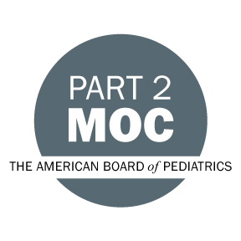

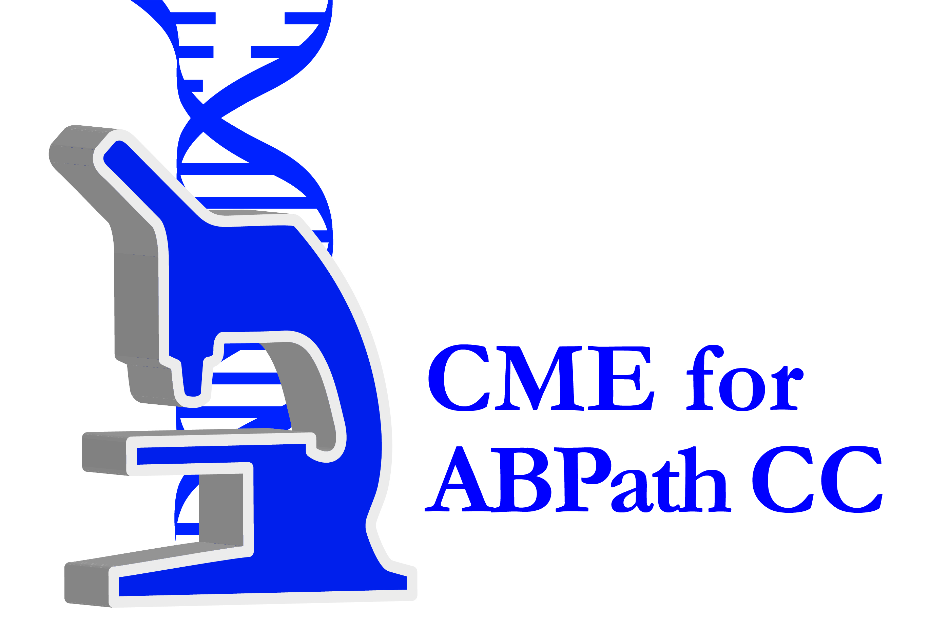



Other Healthcare Professionals
Other healthcare professionals who participate in this activity may submit their statement of participation to their appropriate accrediting organizations or state boards for consideration of credit. Participants are responsible for determining whether this activity meets the requirements for acceptable continuing education.
Disclosures:
AdventHealth Orlando CME adheres to the ACCME’s Standards for Integrity and Independence in Accredited Continuing Education. Any individuals in a position to control the content of a CE activity, including faculty, planners, reviewers or others are required to disclose all relevant financial relationships with ineligible entities (commercial interests). All relevant conflicts of interest have been mitigated prior to the commencement of the activity.

The planners and faculty of this series have disclosed the following financial relationship(s) with ineligible companies/commercial interests:
Name of individual | Individual's role in activity | Nature of Relationship(s) / Name of Ineligible Company(s)
Hezi Cohen, MD | Co-Course Director, Faculty | Nothing to disclose - 12/01/2025

