2026 Signature Safety Seminar (AHC)
Date/Time: | 1/5/2026 7:30:00 AM | Activity ID: | 22405
Location: | Other
Topic | Elevate patient safety at the Signature Safety Seminar—an immersive, interactive workshop designed for healthcare professionals at every level. Dive into the High Reliability Healthcare Framework through dynamic sessions led by subject-matter experts, exploring the four key domains: Culture, Knowledge, Learning Systems, and Leadership. Experience hands-on practicums, engaging discussions, and a special focus on well-being with our #FeelingWhole segment, addressing burnout and its impact on care quality. Join us to gain practical skills, connect with leaders and frontline teams, and help build a safer, more reliable healthcare system. Register now and be part of the movement for excellence in patient safety!
Objectives:
After this activity, the participant will be able to:

1 Identify work settings with strong safety culture and those requiring improvement.
2 Apply proxy measures of patient safety culture, including survey data and near-miss reporting.
3 Describe the multidisciplinary performance improvement framework designed to reduce patient harm and improve outcomes.
4 State the skills that support learning system goals (including curiosity for non-judgmental learning, improvement and measurement methodologies, and reliable design principles).
5 Identify components of the High Reliability Framework and apply related skills and competencies to clinical practice.
Accreditation:

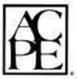

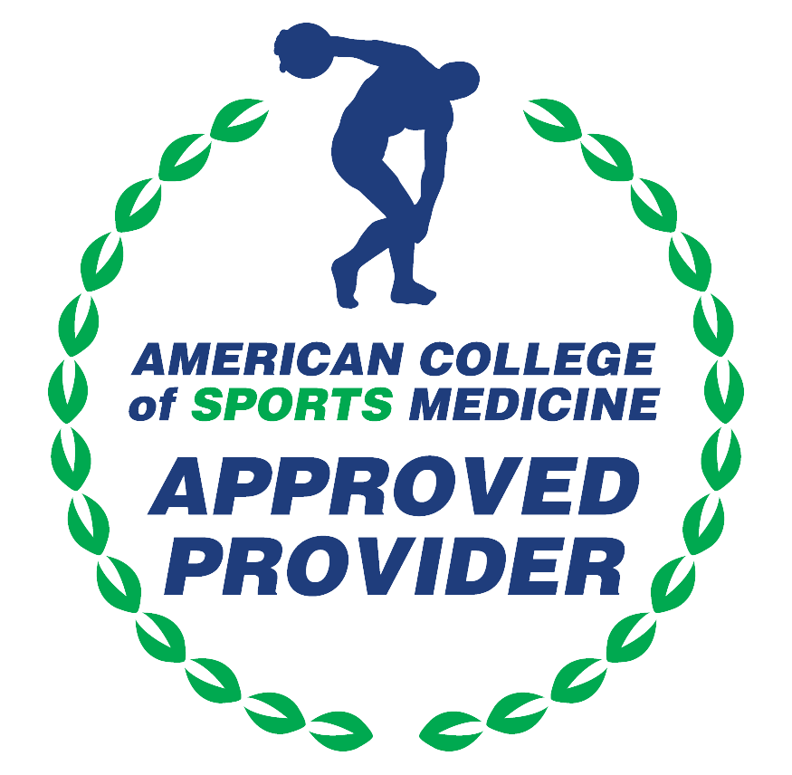

American Medical Association (AMA)
AdventHealth Orlando is accredited by the Florida Medical Association (FMA) to provide continuing medical education for physicians.
AdventHealth Orlando designates this Live Activity for a maximum of 7.00 AMA PRA Category 1 Credit(s)™. Physicians should claim only the credit commensurate with the extent of their participation in the activity.







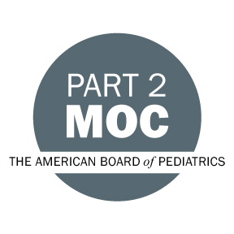

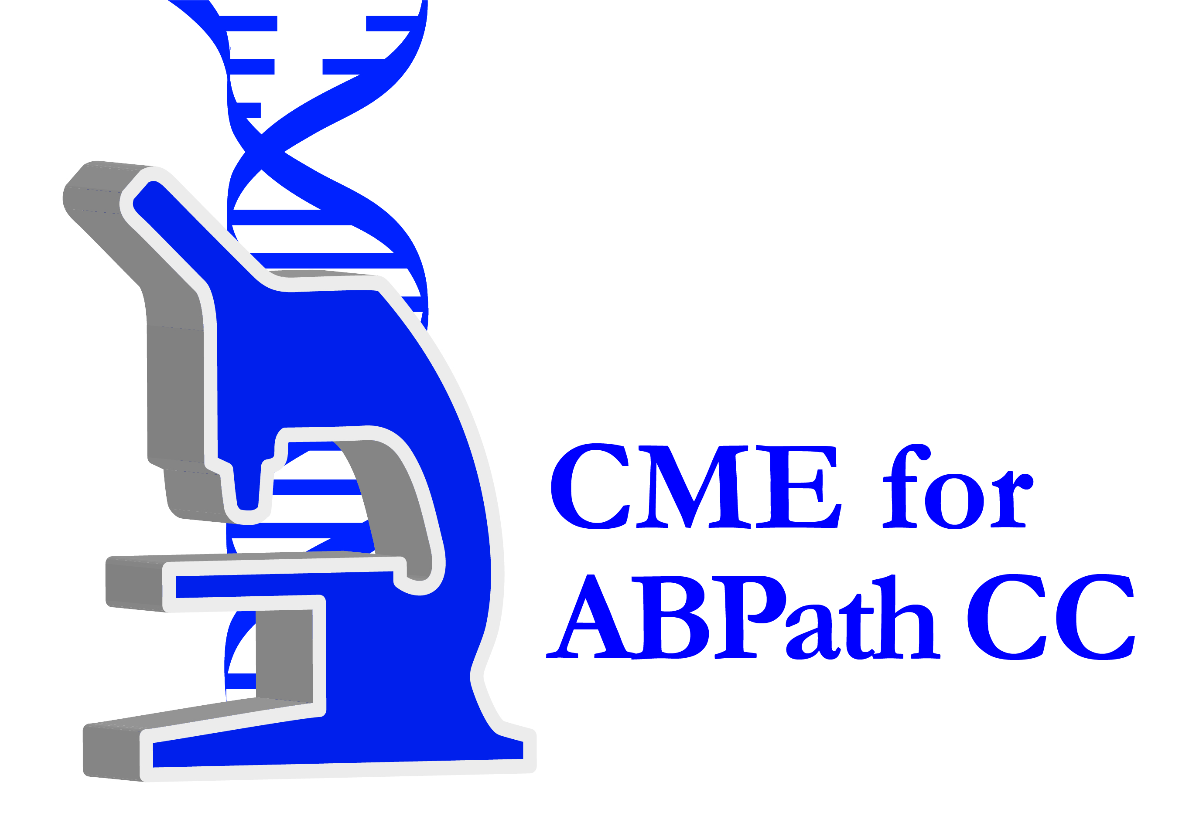

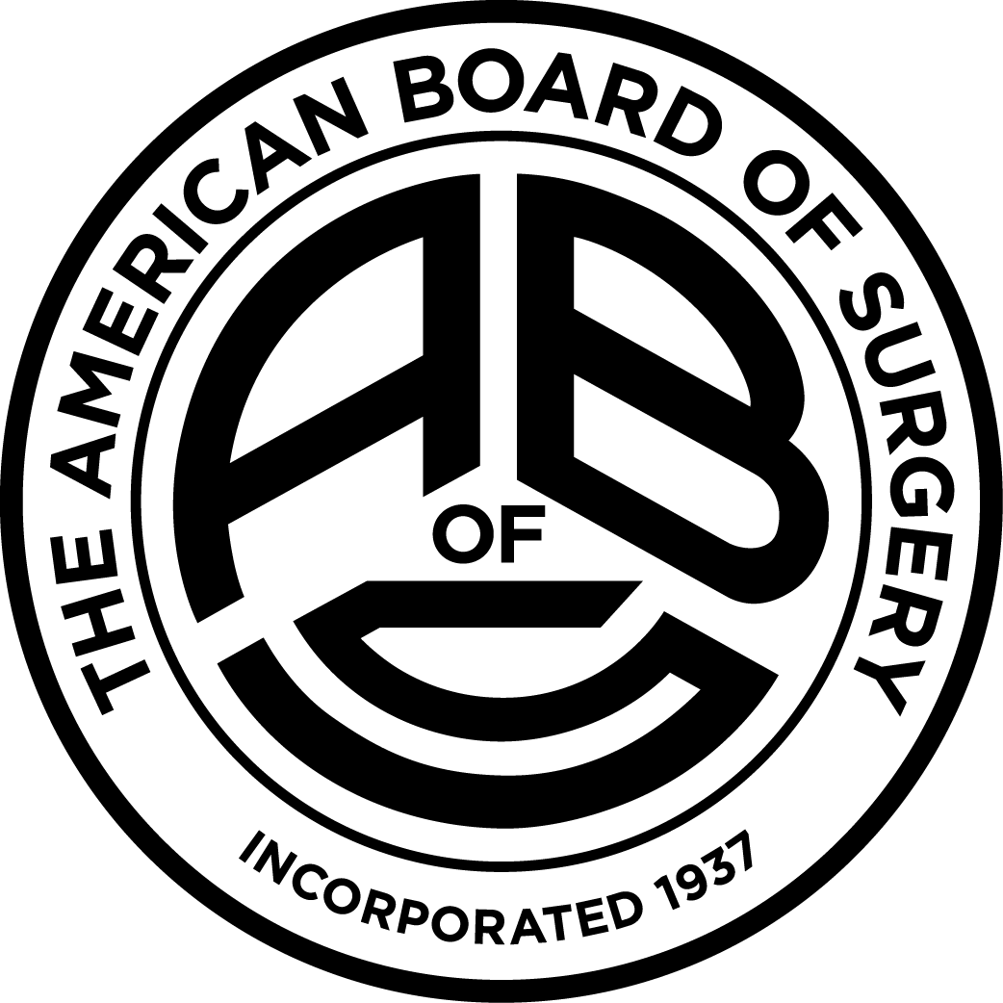

Other Healthcare Professionals
Other healthcare professionals who participate in this activity may submit their statement of participation to their appropriate accrediting organizations or state boards for consideration of credit. Participants are responsible for determining whether this activity meets the requirements for acceptable continuing education.
Disclosures:
AdventHealth Orlando CME adheres to the ACCME’s Standards for Integrity and Independence in Accredited Continuing Education. Any individuals in a position to control the content of a CE activity, including faculty, planners, reviewers or others are required to disclose all relevant financial relationships with ineligible entities (commercial interests). All relevant conflicts of interest have been mitigated prior to the commencement of the activity.

The planners and faculty of this series have disclosed the following financial relationship(s) with ineligible companies/commercial interests:
Name of individual | Individual's role in activity | Nature of Relationship(s) / Name of Ineligible Company(s)
David A. George, BSN, RN, CCRN-K | Faculty | Nothing to disclose - 11/06/2025
Ashleigh A. Gonzalez, MSN, RNC, CPPS | Nurse Planner | Nothing to disclose - 11/21/2025
Mike A. Irwin, BSIE | Faculty | Nothing to disclose - 11/13/2025
Jeffrey C. Kuhlman, MD, MPH, CPPS | Faculty | Nothing to disclose - 10/30/2025
Omayra L. Mansfield, MD, MHA, FACEP | Faculty | Nothing to disclose - 10/28/2025
Amy Reichard, LPN | Activity Coordinator | Nothing to disclose - 10/28/2025
William R. Scharf, MD | Faculty | Nothing to disclose - 11/06/2025
Teresa M. Tomlinson, MSN | Course Director | Nothing to disclose - 10/28/2025

