2024 AHCI Best of ASCO
Date/Time: | 8/17/2024 7:00:00 PM | Activity ID: | 18365
Location: | JW Marriott Orlando, Grande Lakes
Topic | The officially licensed AHCI 11th Annual Best of ASCO conference facilitates a forum for local and statewide physicians to participate and learn the foremost research and strategies in oncology from the highest rated abstracts presented at the Annual ASCO meeting.
Objectives:
After this activity, the participant will be able to:

1 Summarize the data presented at ASCO® 2024 and practice application in clinical settings.
2 Examine advances in treatment strategies for patients with hematologic malignancies and solid tumors.
3 Evaluate the role of new diagnostic techniques and therapeutic approaches in the care and management of cancer patients
4 Interpret updates in evidence-based guidelines, regulations, clinical and translational research, and precision medicine
Accreditation:





American Medical Association (AMA)
AdventHealth Orlando is accredited by the Florida Medical Association (FMA) to provide continuing medical education for physicians.
AdventHealth Orlando designates this Live Activity for a maximum of 9.00 AMA PRA Category 1 Credit(s)™. Physicians should claim only the credit commensurate with the extent of their participation in the activity.







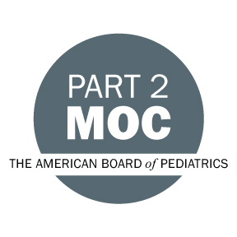

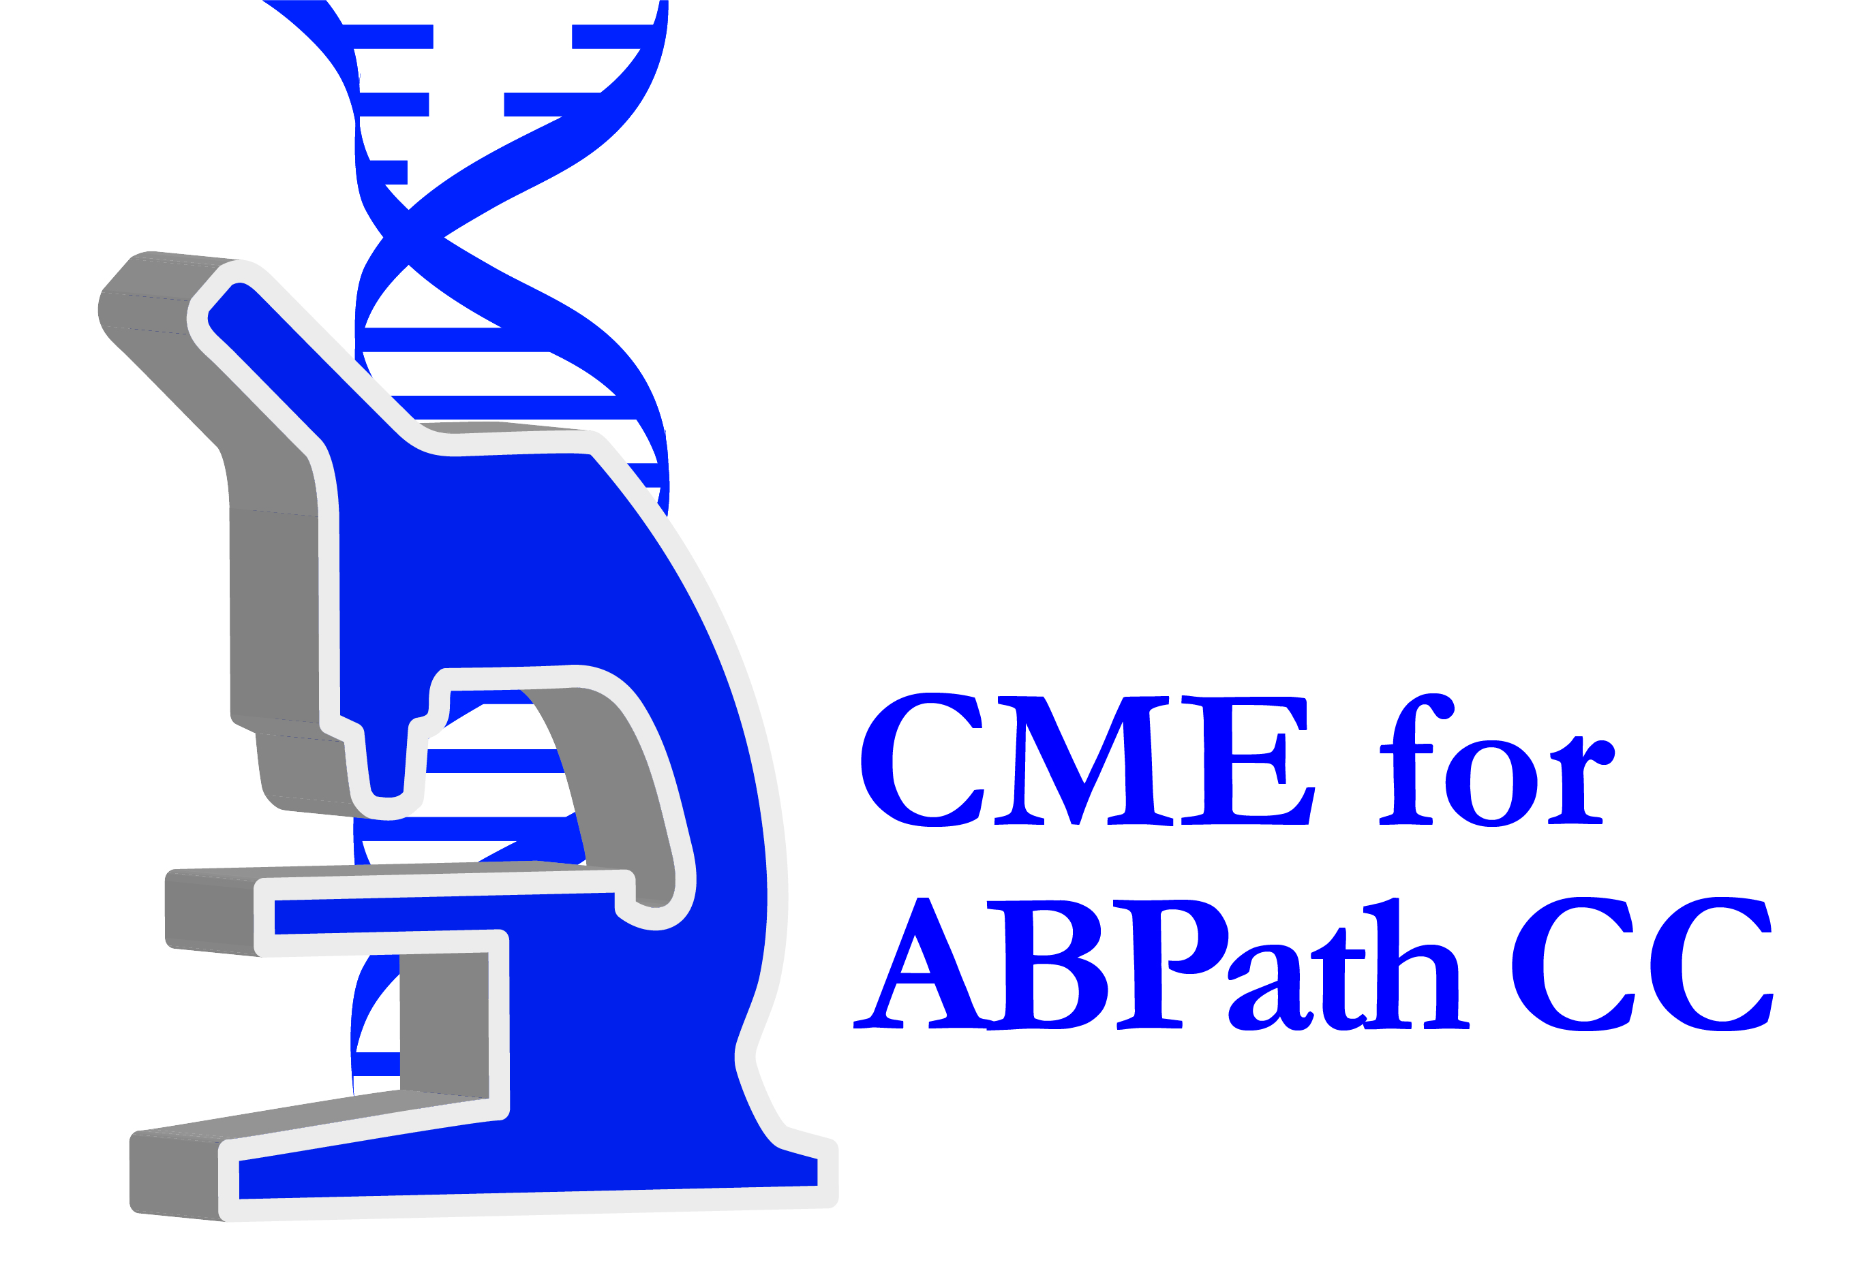


American Board of Surgery Continuing Certification
Successful completion of this CME activity, which includes participation in the evaluation component, enables the learner to earn 9.00 credit towards the CME requirement of the American Board of Surgery’s Continuous Certification program. It is the CME activity provider’s responsibility to submit learner completion information to ACCME for the purpose of granting ABS credit.

Other Healthcare Professionals
Other healthcare professionals who participate in this activity may submit their statement of participation to their appropriate accrediting organizations or state boards for consideration of credit. Participants are responsible for determining whether this activity meets the requirements for acceptable continuing education.
Disclosures:
AdventHealth Orlando CME adheres to the ACCME’s Standards for Integrity and Independence in Accredited Continuing Education. Any individuals in a position to control the content of a CE activity, including faculty, planners, reviewers or others are required to disclose all relevant financial relationships with ineligible entities (commercial interests). All relevant conflicts of interest have been mitigated prior to the commencement of the activity.

The planners and faculty of this series have disclosed the following financial relationship(s) with ineligible companies/commercial interests:
Name of individual | Individual's role in activity | Nature of Relationship(s) / Name of Ineligible Company(s)
Bruce D. Cheson, MD, FACP, FAAAS, FASCO | Faculty | Consulting Fee-Abbott Laboratories|Advisor-Pharmacyclics, Inc.|Speakers Bureau-Eli Lilly and Company|Advisor-Merck and Company, Inc. (Relationship has ended) - 09/19/2023
Ryan A. Durfee, MD, FAAOS | Faculty | Advisor-Carbofix Implants - 12/12/2023
Daniel Fassett, MD | Faculty | Paid consultant-Aesculap Implant systems - 05/19/2024
Jorge A. Garcia, MD, FACP | Faculty | Consulting Fee-Aptitude - 09/11/2023
Robert W. Holloway, MD, DHc, FACOG, FACS | Faculty | Speakers Bureau-Eisai, Inc. (Relationship has ended)|Speakers Bureau-GlaxoSmithKline|Speakers Bureau-AstraZeneca|Speakers Bureau-Merck and Company, Inc.|Stocks or stock options, excluding diversified mutual funds-Genelux, San Diego|Speakers Bureau-Natera|Speakers Bureau-Caris Life Sciences - 07/15/2024
Tom E. Hutson, DO, PharmD, PhD, FACP | Faculty | Nothing to disclose - 08/28/2023
David H. Ilson, MD, PhD | Faculty | Advisor-AstraZeneca|Advisor-Bayer Corporation (Relationship has ended)|Advisor-Eli Lilly and Company|Advisor-Bristol-Myers Squibb|Advisor-Genentech, Inc. (Relationship has ended)|Advisor-Merck and Company, Inc.|Advisor-Daiichi Sankyo|Advisor-AMGEN|Advisor-Astellas|Advisor-Taiho - 06/11/2024
John M. Kirkwood, MD | Faculty | Consulting Fee-Amgen (Relationship has ended)|Consulting Fee-Ankyra Therapeutics|Consulting Fee-Applied Clinical Intelligence LLC (Relationship has ended)|Consulting Fee-Axio Research LLC|Consulting Fee-Boxer Capital|Consulting Fee-BMS|Consulting Fee-Cancer Network (Relationship has ended)|Consulting Fee-Checkmate Pharmaceuticals (Relationship has ended)|Consulting Fee-CytomX Therapeutics (Relationship has ended)|Consulting Fee-DermTech (Relationship has ended)|Consulting Fee-Engage Health Media|Consulting Fee-Immunocore LLC (Relationship has ended)|Consulting Fee-iOnctura (Relationship has ended)|Consulting Fee-Iovance Biotherapeutics (Relationship has ended)|Consulting Fee-IQVIA|Consulting Fee-Istari Oncology|Consulting Fee-Jazz Pharmaceuticals, Inc. (Relationship has ended)|Membership on Advisory Committees or Review Panels, Board Membership, etc.-Lytix Biopharma AS|Consulting Fee-Magnolia Innovation LLC (Relationship has ended)|Consulting Fee-Merck and Company, Inc.|Consulting Fee-Natera Inc.|Consulting Fee-Novartis AG|Consulting Fee-Oncocyte Corporation|Consulting Fee-PathAI|Consulting Fee-Pfizer, Inc.|Consulting Fee-Piper Sandler & Co.|Consulting Fee-PyrOjas Corporation|Consulting Fee-Regeneron Pharmaceuticals, Inc.|Consulting Fee-Replimune|Consulting Fee-Scopus BioPharma, Inc.|Consulting Fee-SR One Capital Management LP (Relationship has ended)|Consulting Fee-Takeda Pharmaceuticals, Inc.|Consulting Fee-Valar Labs, Inc.|Grant or research support-Amgen|Grant or research support-BMS|Grant or research support-Checkmate Pharmaceuticals|Grant or research support-Harbour BioMed (Relationship has ended)|Grant or research support-Immvira Pharma Co.|Grant or research support-Immunocore LLC|Grant or research support-Iovance Biotherapeutics|Grant or research support-Lion Biotechnologies, Inc.|Grant or research support-Lytix Biopharma AS|Grant or research support-Novartis AG|Grant or research support-Takeda Pharmaceuticals, Inc.|Grant or research support-Verastem Inc.|Consulting Fee-Cancer Study Group (Relationship has ended) - 06/26/2024
Shaji K. Kumar, MD | Faculty | Membership on Advisory Committees or Review Panels, Board Membership, etc.-Bristol-Myers Squibb|Membership on Advisory Committees or Review Panels, Board Membership, etc.-Johnson and Johnson|Membership on Advisory Committees or Review Panels, Board Membership, etc.-Sanofi-Aventis|Membership on Advisory Committees or Review Panels, Board Membership, etc.-Abbott Laboratories|Membership on Advisory Committees or Review Panels, Board Membership, etc.-Regeneron - 05/31/2024
Rogerio Lilenbaum, MD | Faculty | Nothing to disclose - 07/16/2024
Tarek M. Mekhail, MD, MSc, FRCSI, FRCSEd | Co-Director, Faculty | Speakers Bureau-AstraZeneca|Speakers Bureau-Bristol-Myers Squibb|Speakers Bureau-Eli Lilly and Company|Speakers Bureau-Genentech, Inc.|Speakers Bureau-Merck and Company, Inc.|Speakers Bureau-Novartis AG (Relationship has ended)|Speakers Bureau-Sanofi-Aventis (Relationship has ended)|Speakers Bureau-Takeda Pharmaceuticals, Inc.|Speakers Bureau-Coherus - 12/23/2023
Joyce O'Shaughnessy, MD | Faculty | Honoraria-AstraZeneca|Honoraria-Daiichi Sankyo|Honoraria-Eisai, Inc.|Honoraria-Eli Lilly and Company|Honoraria-F. Hoffmann La Roche Ltd.|Honoraria-GE Healthcare Bio-Sciences|Honoraria-Genentech, Inc.|Honoraria-Genzyme Corporation|Honoraria-Gilead|Honoraria-GlaxoSmithKline|Honoraria-Johnson and Johnson|Honoraria-Merck and Company, Inc.|Honoraria-Novartis AG|Honoraria-Pfizer, Inc.|Honoraria-Pharmacyclics, Inc.|Honoraria-Roche|Honoraria-Sanofi-Aventis|Honoraria-Takeda Pharmaceuticals, Inc. - 06/12/2024
Shubham Pant, MD | Faculty | Nothing to disclose - 06/19/2024
Mark A. Socinski, MD | Course Director, Faculty | Membership on Advisory Committees or Review Panels, Board Membership, etc.-Genentech, Inc.|Speakers Bureau-AstraZeneca|Speakers Bureau-Bristol-Myers Squib Aventis|Honoraria-Bayer Corporation|Speakers Bureau-Guardant Health|Membership on Advisory Committees or Review Panels, Board Membership, etc.-Merck and Company, Inc.|Membership on Advisory Committees or Review Panels, Board Membership, etc.-Roche|Membership on Advisory Committees or Review Panels, Board Membership, etc.-Eli Lilly and Company|Membership on Advisory Committees or Review Panels, Board Membership, etc.-Mirati Therapeutics|Membership on Advisory Committees or Review Panels, Board Membership, etc.-Janssen Oncology|Speakers Bureau-Jazz Pharmaceuticals|Honoraria-Gritstone Bio|Honoraria-Novartis|Speakers Bureau-Sanofi Regeneron|Honoraria-Gilead|Membership on Advisory Committees or Review Panels, Board Membership, etc.-Spectrum Pharmaceuticals|Speakers Bureau-G1 Therapeutics|Honoraria-Coherus Biosciences|Honoraria-Arcus Biosciences|Speakers Bureau-Takeda Pharmaceuticals, Inc.|Grant or research support-Daiichi Sankyo|Speakers Bureau-BluePrint Medicines|Honoraria-GlaxoSmithKline|Speakers Bureau-Amgen|Grant or research support-Enliven|Grant or research support-Cullinan|Grant or research support-Eli Lilly and Company|Speakers Bureau-Eli Lilly and Company - 01/18/2024
Guru P. Sonpavde, MD | Faculty | Consulting Fee-Astellas|Speakers Bureau-Astellas|Speakers Bureau-Seagen|Consulting Fee-Gilead|Grant or research support-Gilead|Speakers Bureau-Gilead|Grant or research support-EMD Serono|Advisor-EMD Serono|Spouse/Life Partner - Employment-Myriad Genetics|Spouse/Life Partner - Employment-Exact Sciences|Other: Editor-Elsevier Practice-update Bladder Cancer|Advisor-Janssen|Speakers Bureau-Janssen|Advisor-Merck and Company, Inc.|Speakers Bureau-Merck and Company, Inc.|Consulting Fee-G1 Therapeutics|Consulting Fee-Scholar Rock|Honoraria-Mereo (Relationship has ended)|Grant or research support-Sanofi-Aventis (Relationship has ended)|Grant or research support-Astrazeneca (Relationship has ended)|Grant or research support-Jazz Pharmaceuticals|Advisor-Eli Lilly and Company|Advisor-Lucence|Advisor-Bicycle Therapeutics|Consulting Fee-Bristol-Myers Squibb|Other: Travel support to conference-Bristol-Myers Squibb (Relationship has ended)|Consulting Fee-Merck and Company, Inc.|Speakers Bureau-Merck and Company, Inc.|Advisor-Tempus|Speakers Bureau-Natera|Speakers Bureau-Exelixis|Consulting Fee-Servier|Consulting Fee-Syapse|Speakers Bureau-Aveo|Speakers Bureau-Bayer Corporation|Grant or research support-Bayer Corporation|Grant or research support-Sumitomo Pharma|Advisor-Scholar Rock|Consulting Fee-Pfizer, Inc.|Speakers Bureau-Pfizer, Inc.|Advisor-Daiichi Sankyo (Relationship has ended)|Grant or research support-Blue Earth Diagnostics|Advisor-Atkis - 07/28/2024
Ayalew Tefferi, MD | Faculty
Frank P. Worden, MD | Faculty | Advisor-EMD Serono (Relationship has ended)|Paid consultant-Exelixis|Advisor-Merck and Company, Inc. (Relationship has ended)|Grant or research support-Merck and Company, Inc.|Advisor-Replimune (Relationship has ended)|Membership on Advisory Committees or Review Panels, Board Membership, etc.-Sun Pharma|Grant or research support-Eli Lilly and Company|Grant or research support-Loxo|Advisor-Adlai|Grant or research support-Adlai|Paid consultant-Eisai, Inc.|Membership on Advisory Committees or Review Panels, Board Membership, etc.-Coherus (Relationship has ended) - 07/01/2024

